**Unitary Test Reports**

**Earth Observation Data Processing**

|  |  |  |  |
| --- | --- | --- | --- |
|  | **Name** | **Function** | **Signature** |
| **Prepared by** | Alberto Ignacio Ruiz Méndez |  |  |
| **Approved by** | Lucía Soto Santiago |  |  |
| **Authorised by** | Lucía Soto Santiago |  |  |

|  |  |
| --- | --- |
| **Date:** | 06/11/2023 |
| **Revision:** | 1.0 |
|  |  |

Revision Record

| **Review** | **Modification reference** | **Change Description** | **Date** |
| --- | --- | --- | --- |
| 1.0 | - | First issue | 14/09/2020 |

Table of Contents

1. Introduction 7

2. References 8

2.1. Applicable Documents 8

2.2. Reference Documents 8

2.3. Acronyms 8

3. EODP-TS-GEO-0001. DEM 9

3.1. Pass/fail Criteria 9

3.1.1. State Vector in ECEF 9

3.1.2. Sun-synchronous Orbit 9

3.1.3. Quaternions in ECEF 9

3.1.4. Geolocation Matrices 9

3.1.5. Acquisition Country 10

3.1.6. Altitude Plots 10

3.2. Summary: PASS/FAIL 10

3.3. Test Results 10

3.3.1. State Vector in ECEF 10

3.3.2. Sun-synchronous Orbit 11

3.3.3. Quaternions in ECEF 12

3.3.4. Geolocation Matrices 12

3.3.5. Acquisition Country 12

3.3.6. Altitude Plots 13

4. EODP-TS-ISM-0001. OPTICAL Stage 15

4.1. Pass/fail Criteria 15

4.1.1. Instrument Spectral Response TOA 15

4.1.2. Optical Stage TOA 15

4.1.3. Radiance to Irradiance Conversion Factor 15

4.1.4. System MTF Plots 16

4.1.5. Border Effect Cause 16

4.1.6. TOA Plots 16

4.2. Summary: PASS/FAIL 16

4.3. Test Results 16

4.3.1. Instrument Spectral Response TOA 16

4.3.2. Optical Stage TOA 17

4.3.3. Radiance to Irradiance Conversion Factor 17

4.3.4. System MTF Plots 17

4.3.5. Border Effect Cause 21

4.3.6. TOA Plots 23

5. EODP-TS-ISM-0002. DETECTION and VIDEO CONVERSION 25

5.1. Pass/fail Criteria 25

5.1.1. Video and Control Unit TOA 25

5.1.2. Conversion Factors 25

5.1.3. Image ‘Stripes’ 26

5.1.4. Saturated Pixels 26

5.1.5. TOA Plots 26

5.2. Summary: PASS/FAIL 27

5.3. Test Results 27

5.3.1. Video and Control Unit TOA 27

5.3.2. Conversion Factors 27

5.3.3. Image ‘Stripes’ 27

5.3.4. Saturated Pixels 28

5.3.5. TOA Plots 29

6. EODP-TS-L1B-0001. EQUALIZATION AND RESTORATION 31

6.1. Pass/fail Criteria 31

6.1.1. LIB TOA 31

6.1.2. Restored Signal and TOA Plots Differences 31

6.1.3. Restored Signal Equalization Comparison 31

6.1.4. Blocked Restoration 31

6.2. Summary: PASS/FAIL 32

6.3. Test Results 32

6.3.1. LIB TOA 32

6.3.2. Restored Signal and TOA Plots Differences 32

6.3.3. Restored Signal Equalization Comparison 34

6.3.4. Blocked Restoration 38

7. EODP-TS-L1C-0001. MGRS 39

7.1. Pass/fail Criteria 39

7.2. Summary: PASS/FAIL 39

7.3. Test Results 39

8. EODP-TS-E2E-0001. TLS. 40

8.1. Pass/fail Criteria 40

8.2. Summary: PASS/FAIL 40

8.3. Test Results 40

9. Summary of test results 41

10. Section 42

10.1. Subsection 42

10.1.1. Subsection 42

10.1.1.1. Subsection 42

10.1.1.1.1. Subsection 42

List of Tables

Table 2‑1: Applicable Documents 8

Table 2‑2: Reference Documents 8

Table 2‑3: Acronyms 8

Table 5‑1: System MTF Values at Nyquist Frequency. 21

Table 5‑1: Conversion Factors Values for all Bands 27

Table 9‑1: Summary of test execution reports 41

List of Figures

Figure 3‑1: Initial State Vector in ECEF. 10

Figure 3‑2: Final State Vector in ECEF. 11

Figure 3‑3: Total Number of State Vectors. 11

Figure 3‑4: Sun-Synchronous Orbit Parameters. 11

Figure 3‑5: First Quaternion in ECEF. 12

Figure 3‑6: Last Quaternion in ECEF. 12

Figure 3‑7: Geolocation Matrices Dimensions. 12

Figure 3‑8: Location of Data Acquisition Country. 13

Figure 3‑9: Altitude Plot. 14

Figure 4‑1: ISRF TOA Difference Check. 16

Figure 4‑2: Optical Stage TOA Difference Check. 17

Figure 4‑3: System MTF slice ACT for VNIR-0 (for the central pixels of ALT). 17

Figure 4‑4: System MTF slice ACT for VNIR-1 (for the central pixels of ALT). 18

Figure 4‑5: System MTF slice ACT for VNIR-2 (for the central pixels of ALT). 18

Figure 4‑6: System MTF slice ACT for VNIR-3 (for the central pixels of ALT). 19

Figure 4‑7: System MTF slice ALT for VNIR-0 (for the central pixels of ACT). 19

Figure 4‑8: System MTF slice ALT for VNIR-1 (for the central pixels of ACT). 20

Figure 4‑9: System MTF slice ALT for VNIR-2 (for the central pixels of ACT). 20

Figure 4‑10: System MTF slice ALT for VNIR-3 (for the central pixels of ACT). 21

Figure 4‑11: Central ACT position of “ism_toa_optical_VNIR-0”. 22

Figure 4‑12: Plot ism_toa_optical_VNIR-0. 23

Figure 4‑13: Plot ism_toa_optical_VNIR-1. 23

Figure 4‑14: Plot ism_toa_optical_VNIR-2. 24

Figure 4‑15: Plot ism_toa_optical_VNIR-3. 24

Figure 5‑1: Video and Control TOA Difference Check. 27

Figure 5‑2: Plot of the final TOA in DN. 28

Figure 5‑2: Percentage of Saturated Pixels per Band. 28

Figure 4‑15: Plot ism_toa_VNIR-0. 29

Figure 4‑15: Plot ism_toa_VNIR-1. 29

Figure 4‑15: Plot ism_toa_VNIR-2. 30

Figure 4‑15: Plot ism_toa_VNIR-3. 30

Figure 5‑1: L1B TOA Difference Check. 32

Figure 5‑1: Restored Signal vs ISRF TOA - VNIR-0 (for central ALT position). 32

Figure 5‑1: Restored Signal vs ISRF TOA - VNIR-1 (for central ALT position). 33

Figure 5‑1: Restored Signal vs ISRF TOA - VNIR-2 (for central ALT position). 33

Figure 5‑1: Restored Signal vs ISRF TOA - VNIR-3 (for central ALT position). 34

Figure 5‑1: L1B TOA Equalization Comparison – VNIR-0. 35

Figure 5‑1: L1B TOA Equalization Comparison – VNIR-1. 36

Figure 5‑1: L1B TOA Equalization Comparison – VNIR-2. 37

Figure 5‑1: L1B TOA Equalization Comparison – VNIR-3. 38

Figure 10‑1: ISS low-res (weak). 42

# Introduction

This document provides the Unitary Test Reports for each of the algorithms specified in [EODP_ATBD] and whose test is specified in [EODP_SPE].

# References

## Applicable Documents

Table ‑: Applicable Documents

| **Ref.** | **Code** | **Title** | **Issue** |
| --- | --- | --- | --- |
| [EODP_ATBD] | - | EODP Algorithm Theoretical Baseline Document | 1.0 |
| [EODP_SPE] | - | EODP Unitary Test Specifications | 1.0 |

## Reference Documents

Table ‑: Reference Documents

| **Ref.** | **Code** | **Title** | **Issue** |
| --- | --- | --- | --- |
|  |  |  |  |

## Acronyms

Table ‑: Acronyms

| **Acronym** | **Description** |
| --- | --- |
| AD | Applicable Document |
| FYI | For Your Information |
| ISS | International Space Station |
| RD | Reference Document |
| TN | Technical Note |

# EODP-TS-GEO-0001. DEM

The goal of this test is to run the Geometry Module (GM) and to acquaint oneself with the EOCFIs. The Geometry Module is delivered as a functional code, no implementation is needed. In this test the GM shall be run with a DEM, and the goal is to obtain the profile of the altitudes.

## Pass/fail Criteria

The PASS/FAIL criteria defined for the Geometry Module contains the following test with a summarized justification of how they were obtained.

### State Vector in ECEF

* **Criteria**: What is the first and last state vector in ECEF; how many state vectors there are. Verify that the number of samples is coherent with the duration of the acquisition and the sampling time.

To identify the initial and final state vectors and calculate the total count of state vectors, you should examine the "*real_orbit.xml*" file within the designated GM output folder. It can be verified the number of samples, acquisition duration, and sampling time (available in "gm_local_conf.xml") by performing the following calculations:

* To determine the acquisition duration, multiply the sampling time by the number of samples.
* To find the sampling time, divide the number of samples by the acquisition duration.

### Sun-synchronous Orbit

* **Criteria**: What is the Sun-synchronous orbit (defined in the Orbit Scenario File in the auxiliary folder).

The parameters governing the sun-synchronous orbit are specified within the auxiliary folder, “*osf_sentinel2a.xml*”. The essential parameters to be verified include the repeat cycle, cycle length, ANX longitude, MLST, and MLST drift. These specific parameters define the sun-synchronous orbit.

### Quaternions in ECEF

* **Criteria**: What is the first and last quaternion in ECEF.

To ascertain the initial and final quaternions, it's essential to inspect the "*real_attitude.xml*" file situated within the chosen GM output directory.

### Geolocation Matrices

* **Criteria**: What is the size of the geolocation matrices (lat, lon, alt).

The dimensions of the geolocation matrices can be found in the "*geolocation.nc*" file within the designated GM output folder. To access the projection images containing altitude, latitude, and longitude, open this file using Panoply. Finally, ensure you examine the file dimensions, specifically the variables "*n_lines*" and "n_columns."

### Acquisition Country

* **Criteria**: Over which country is the acquisition passing; what DEM file do you need to use.

After importing the geolocation file into Panoply, it is possible to observe the country through which the acquisition transpires. Following this, the DEM file can be procured by conducting a search within the ESA GETASSE repository. It is crucial to emphasize that the correct DEM file must be determined by referencing the South-West corner of the image's covered area.

### Altitude Plots

* **Criteria**: Plot the altitudes (in Panoply). Verify that the altitudes are not zeros (the simulation is correctly using the DEM).

After updating the relevant DEM file, altitudes can be plotted using Panoply. To verify the accuracy of the data, a comparison can be conducted between the data array obtained from Panoply and a thorough check to ensure that there are no zero values.

## Summary: PASS/FAIL

This exercise is a **PASS**.

## Test Results

This section contains the results, plots and descriptions that supports the pass/fail criteria.

### State Vector in ECEF

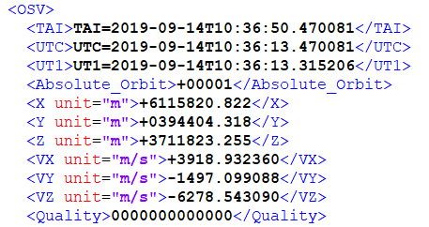

Figure 3‑1: Initial State Vector in ECEF.

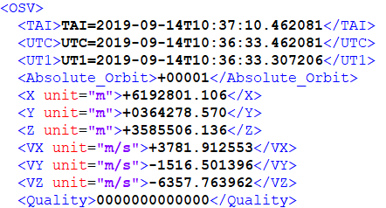

Figure 3‑2: Final State Vector in ECEF.



Figure 3‑3: Total Number of State Vectors.

Considering the configuration parameters specified in the [EODP_SPE] for both the total propagation time (20 seconds) and the sampling time (0.00672 seconds, it is readily ascertainable that the total count of samples aligns with these defined values.

In accordance with this configuration, if one were to divide the total propagation time or acquisition duration by the number of samples, it should yield the sampling time as the result. Thus:

$$t_{sampling}= \frac{t_{prop}}{N_{samples}}= \frac{20}{2976}=0.00672 s$$

Conversely, when the sampling time is multiplied by the number of samples, it should yield the total propagation time as the outcome.

$$t_{prop}= t_{sampling}∙N_{samples}=0.00672 ∙2976=20 s$$

### Sun-synchronous Orbit

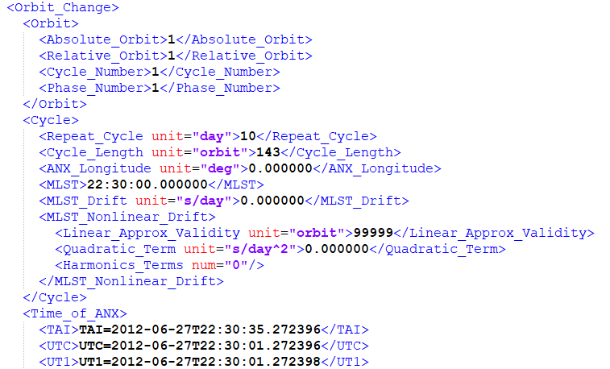

Figure 3‑4: Sun-Synchronous Orbit Parameters.

### Quaternions in ECEF

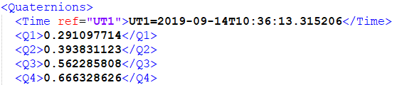

Figure 3‑5: First Quaternion in ECEF.

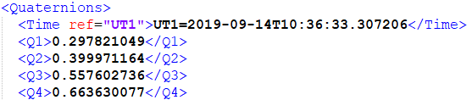

Figure 3‑6: Last Quaternion in ECEF.

### Geolocation Matrices

The number of lines and columns is obtained from Panoply. Therefore, the geolocation matrices (latitude, longitude and altitude) dimensions are **2976 x 1000**.

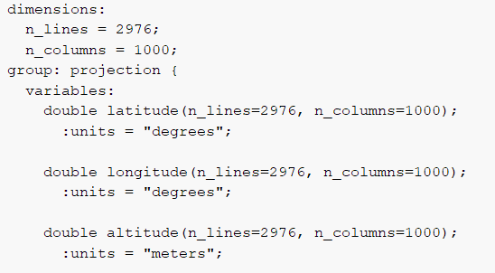

Figure 3‑7: Geolocation Matrices Dimensions.

### Acquisition Country

In Figure 3‑8, a depiction of the acquisition path in terms of latitude is presented alongside the corresponding geographical coordinates, including latitude and longitude (in this case, approximate values of 30.8°N and 3.55°E, respectively), displayed in Google Earth.

Upon examining Figure 3‑8, it is evident that the country encompassing the acquisition path is Algeria.

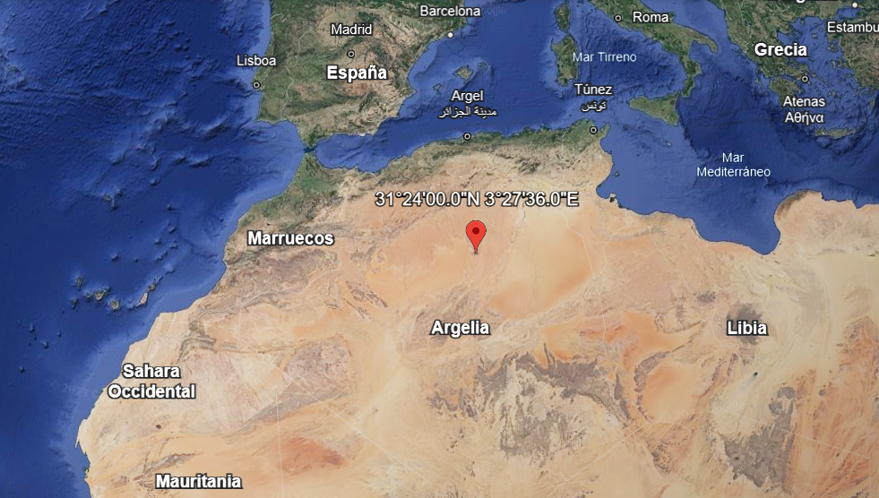

1. Google Earth Location

|  |  |
| --- | --- |
|  |  |
| 1. Panoply Location, Latitude Plot | 1. Panoply Location, Latitude Plot |

Figure 3‑8: Location of Data Acquisition Country.

To accurately select the appropriate Digital Elevation Model (DEM) file from the ESA GETASSE repository, one must focus on the South-West corner of the imaged area. As mentioned earlier, an estimated midpoint of the acquisition path is situated at approximately 30.8°N and 3.55°E. Consequently, the corresponding South-West corner coordinates are approximately 30.0°N and 0.0°E, considering that the set of Digital Elevation Model tiles covers an area spanning 15 degrees of longitude by 15 degrees of latitude. The requisite DEM file in this case is "***30N000E.GETASSE30***."

### Altitude Plots

After updating the DEM file, altitude data can be visualized and plotted using Panoply, as demonstrated in Figure 3‑9. A straightforward method to confirm the presence of non-zero values within the altitude array is to examine this figure. The minimum value for altitude, which is 335.1 meters, serves as the reference point on the color bar. In the event of encountering a zero value, it would correspond to the lower limit of the color scale.

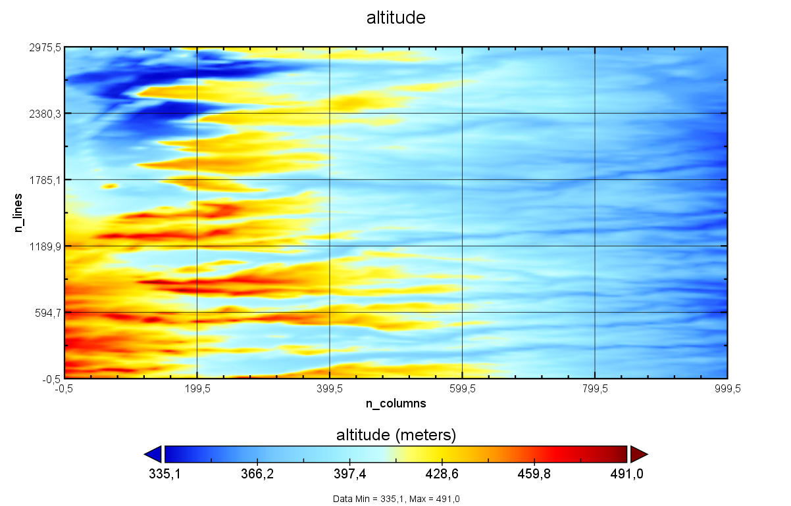

Figure 3‑9: Altitude Plot.

# EODP-TS-ISM-0001. OPTICAL Stage

The goal of this test is to run the ISM Module and to check the optical stage: the spectral integration of

the ISRF filter, the conversion of radiances to irradiances and the spatial filter (MTF).

## Pass/fail Criteria

The PASS/FAIL criteria defined for the ISM Module contains the following test with a summarized justification of how they were obtained.

### Instrument Spectral Response TOA

* **Criteria**: Check for all bands that the differences with respect to the output TOA (ism_toa_isrf) are <0.01% for

at least 3-sigma of the points.

To ascertain that the disparities between the ISRF obtained, in comparison to the reference values located in the “*EODP-TS-ISM”* folder, remain below the threshold of 0.01%, a script named "*Test_ISM_Optical_Stage.py*" has been developed. This script facilitates the calculation of deviations between the obtained outputs and reference outputs by performing a straightforward subtraction operation and subsequently displaying the resultant values.

### Optical Stage TOA

* **Criteria**: Check for all bands that the differences with respect to the output TOA (ism_toa_optical) are <0.01%

for at least 3-sigma of the points.

To ascertain that the disparities after the optical stage obtained, in comparison to the reference values located in the “*EODP-TS-ISM”* folder, remain below the threshold of 0.01%, a script named "*Test_ISM_Optical_Stage.py*" has been developed. This script facilitates the calculation of deviations between the obtained outputs and reference outputs by performing a straightforward subtraction operation and subsequently displaying the resultant values.

### Radiance to Irradiance Conversion Factor

* **Criteria**: What is the radiance to irradiance conversion factor for each band. What are the units of the TOA at

this stage.

The conversion factor can be derived by the equation which facilitates the transformation of radiances into irradiances. The equation is expressed as follows:

$$I= T_{r}∙L∙\frac{π}{4}∙{\left(\frac{D}{f}\right)}^{2}$$

Where

$I$ is the irradiance expressed per ground area

$T_{r}$ is the optical transmittance

$L$ is the radiance of the ground

$D$ is the telescope pupil diameter

$f$ is the focal length in meters

Consequently, the conversion factor is defined as:

$$Conversion Factor= T_{r}∙\frac{π}{4}∙{\left(\frac{D}{f}\right)}^{2}$$

The units of TOA measurements at this stage are expressed in radiances as [mW/sr · m²]. Following the conversion process, these TOA units are transformed into irradiances, denoted as [mW/m²].

### System MTF Plots

* **Criteria**: Plot for all bands the System MTF across and along track (for the central pixels). Report the MTF at

the Nyquist frequency. Explain whether this is a decent or mediocre value and why.

The MTF implementation can be found within the "*mtf.py*" file situated in the "*ism*" folder.

### Border Effect Cause

* **Criteria**: Explain the cause of the border effect introduced by the spatial filter (MTF) and what would be an

appropriate solution (if any). How many pixel lines does it affect (roughly).

Explanation included in section [4.3.5]

### TOA Plots

* **Criteria**: Plot the TOA for all bands after the optical stage (with Panoply).

Following the completion of MTF and the optical stage module implementation, the TOA plots after the optical stage will be displayed using Panoply.

## Summary: PASS/FAIL

This exercise is a **PASS**.

## Test Results

### Instrument Spectral Response TOA









Figure 4‑1: ISRF TOA Difference Check.

### Optical Stage TOA









Figure 4‑2: Optical Stage TOA Difference Check.

### Radiance to Irradiance Conversion Factor

$$Conversion Factor= T_{r}∙\frac{π}{4}∙{\left(\frac{D}{f}\right)}^{2}=0.99∙\frac{π}{4}∙{\left(\frac{0.150}{0.5262}\right)}^{2}=0.0632$$

### System MTF Plots

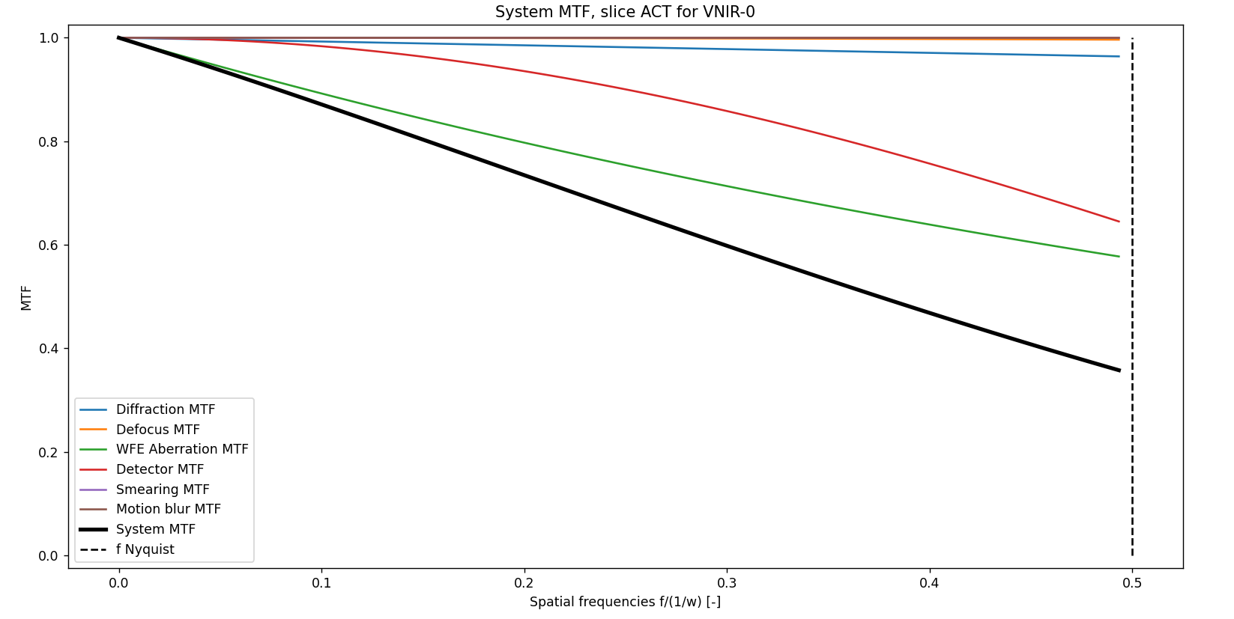

Figure 4‑3: System MTF slice ACT for VNIR-0 (for the central pixels of ALT).

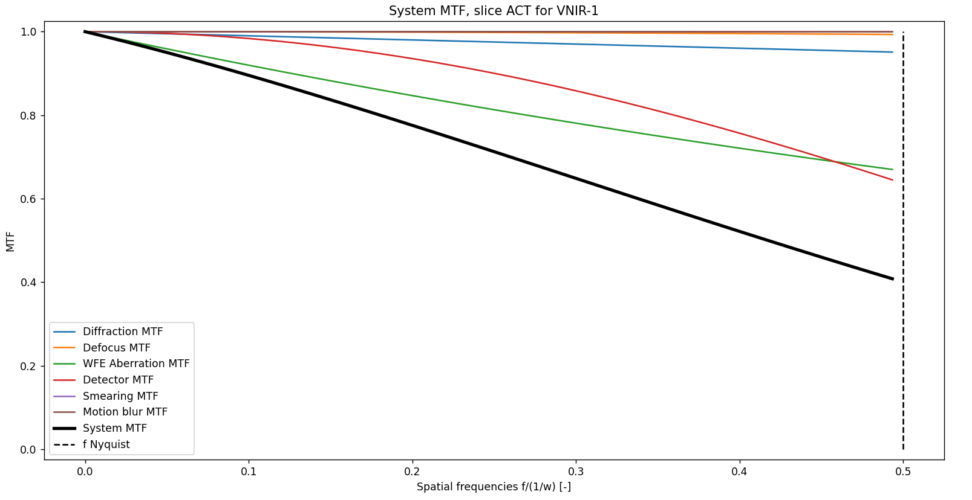

Figure 4‑4: System MTF slice ACT for VNIR-1 (for the central pixels of ALT).

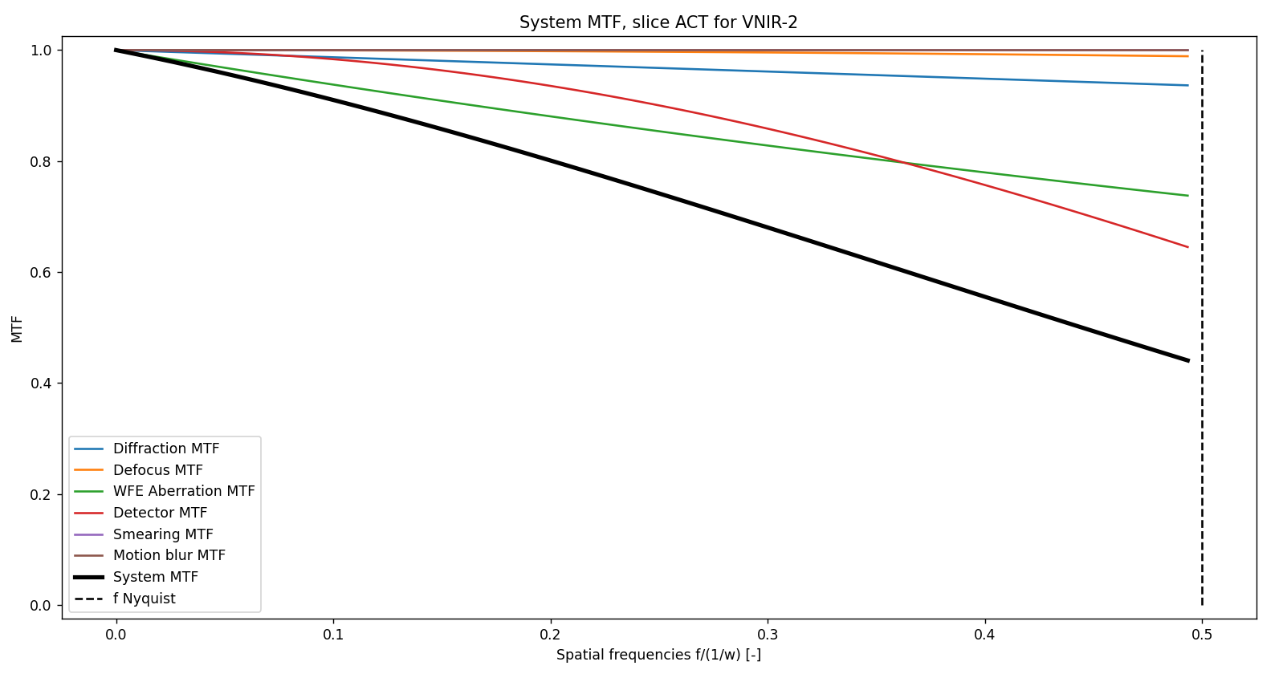

Figure 4‑5: System MTF slice ACT for VNIR-2 (for the central pixels of ALT).

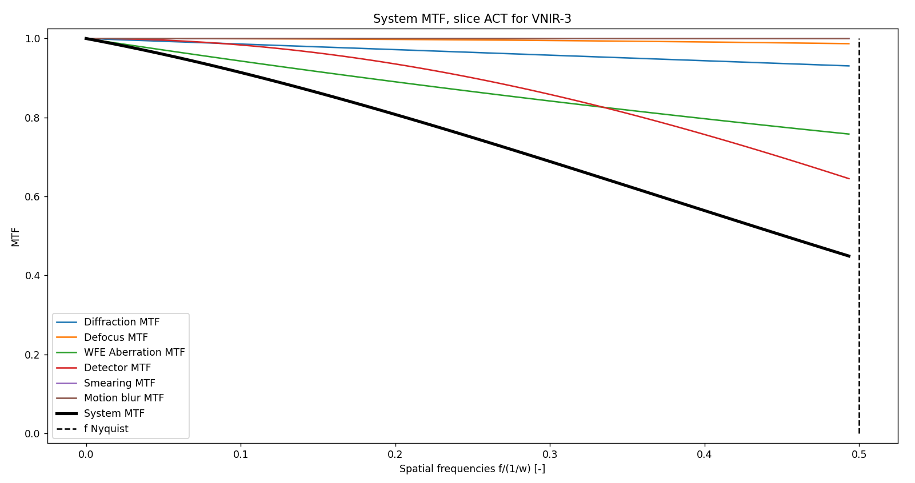

Figure 4‑6: System MTF slice ACT for VNIR-3 (for the central pixels of ALT).

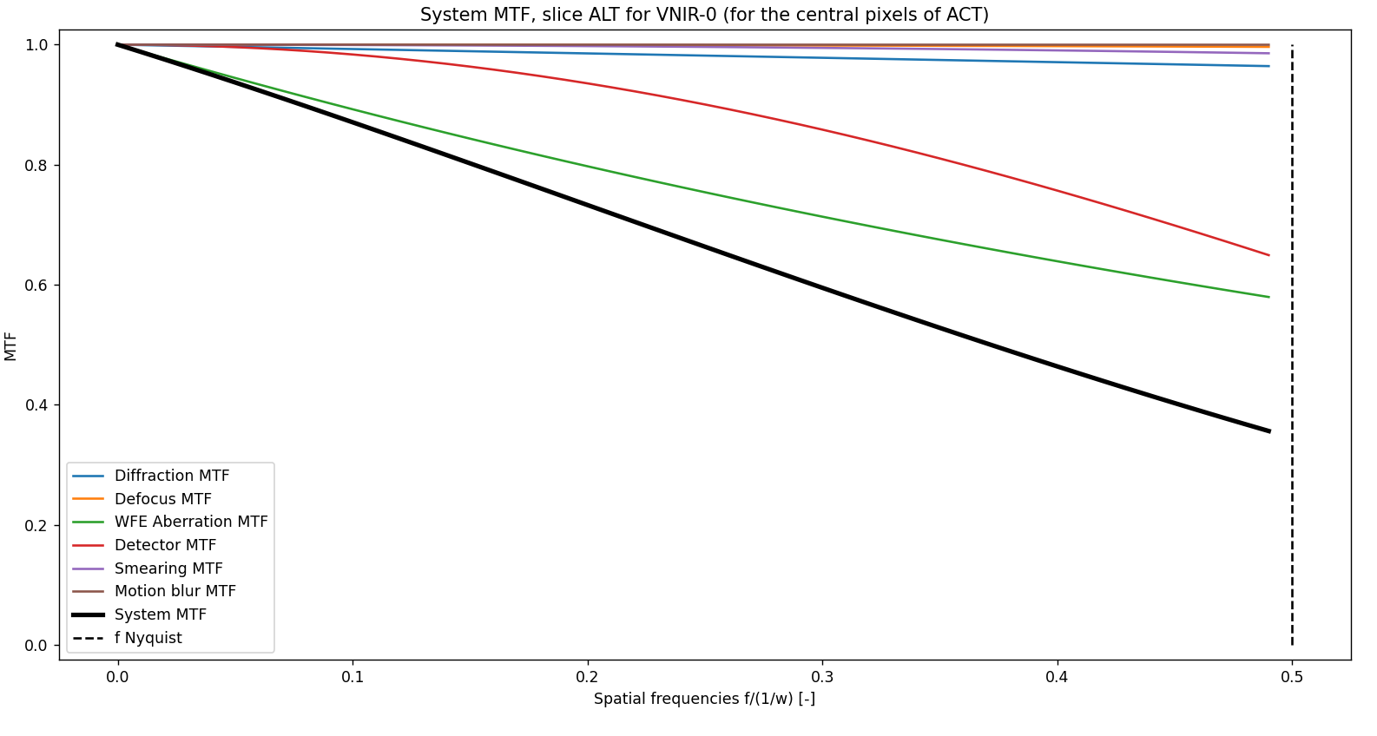

Figure 4‑7: System MTF slice ALT for VNIR-0 (for the central pixels of ACT).

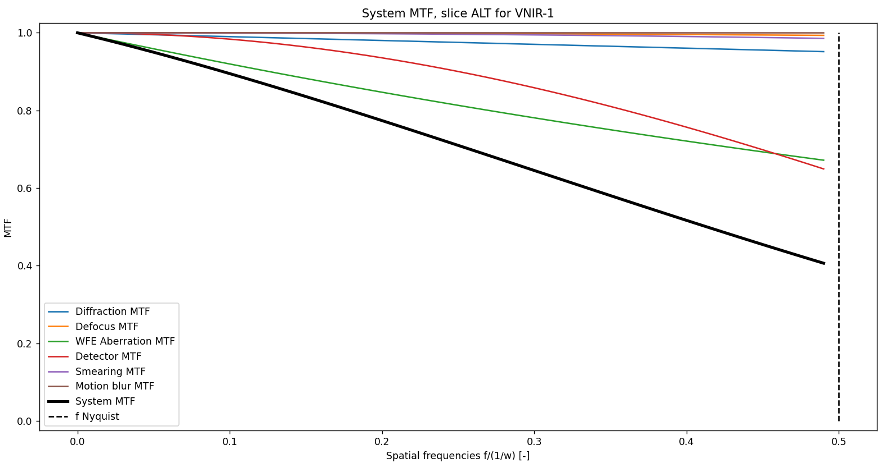

Figure 4‑8: System MTF slice ALT for VNIR-1 (for the central pixels of ACT).

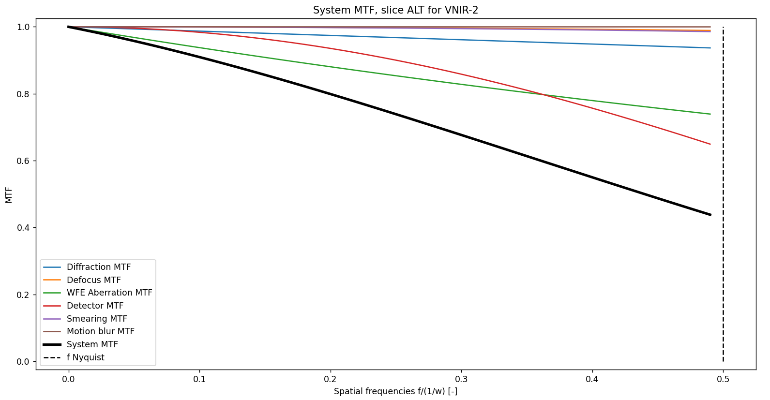

Figure 4‑9: System MTF slice ALT for VNIR-2 (for the central pixels of ACT).

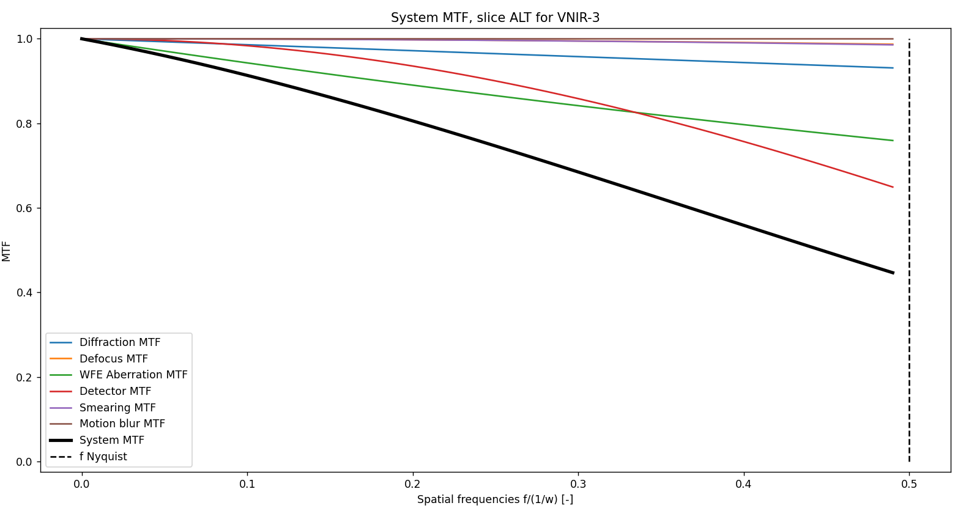

Figure 4‑10: System MTF slice ALT for VNIR-3 (for the central pixels of ACT).

Table 4‑1: System MTF Values at Nyquist Frequency.

|  |  |  |
| --- | --- | --- |
|  | **System MTF ACT Values** | **System MTF ALT Values** |
| **VNIR-0** | 0.357 | 0.356 |
| **VNIR-1** | 0.408 | 0.406 |
| **VNIR-2** | 0.441 | 0.438 |
| **VNIR-3** | 0.449 | 0.447 |

### Border Effect Cause

Border effects manifest during the application of image processing. Image processing involves the utilization of neighbouring input pixels, and as a consequence, the output values become undefined in the vicinity of the image borders.

Typically, border effects become pronounced following convolution operations, as is the case with the MTF application. When convolutions are performed on signals with finite lengths, border distortions become evident. Figure 4-5 serves as an illustrative example of these border effects, observable at the initial and final sections of the curve.

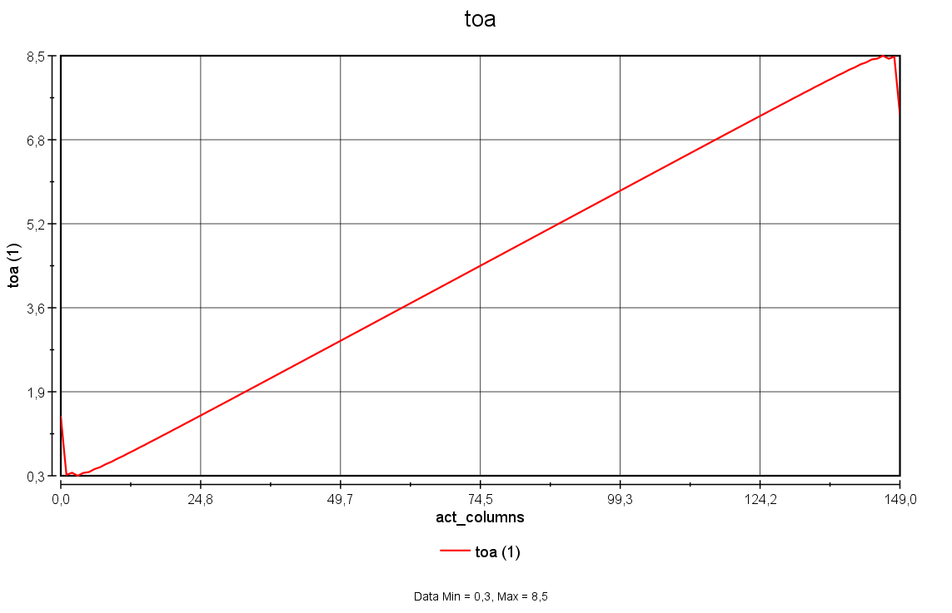

Figure 4‑11: Central ACT position of “ism_toa_optical_VNIR-0”.

Addressing border or edge defects entails various steps, such as:

Creating a margin around the image, where "fake" pixels are simulated in both the ACT and ALT directions. These are subsequently removed after the spatial filtering process. To perform convolution with the Point Spread Function (PSF), it suffices to have a margin equivalent to half the kernel size. For multiplication with the MTF, a larger margin, typically spanning 2 to 3 pixels, is preferable. This approach aims to rectify border effects introduced during convolution by accounting for the erroneous pixels and eliminating them post-spatial filtering.

Employing spatial oversampling on the input TOA data, thereby increasing the sampling rate to mitigate edge effects. Following the application of spatial filtering, the image is subsequently down sampled to its native resolution. This step complements the previous one by providing higher pixel resolution.

Numerous methods from existing literature can be utilized to mitigate border effects, including zero-padding, symmetrization, smooth padding, and periodic padding

### TOA Plots

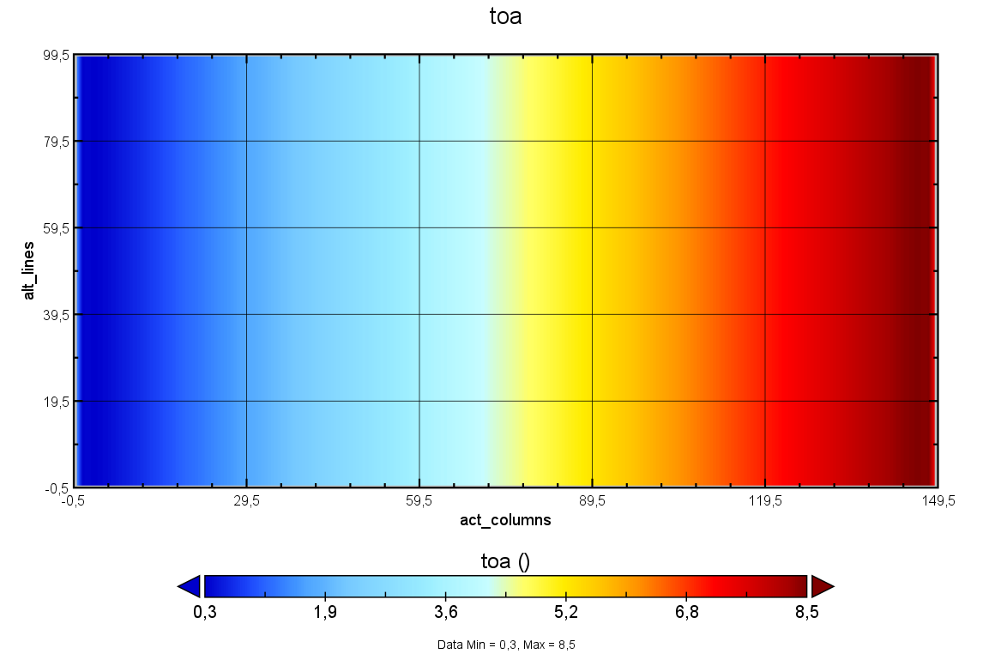

Figure 4‑12: Plot ism_toa_optical_VNIR-0.

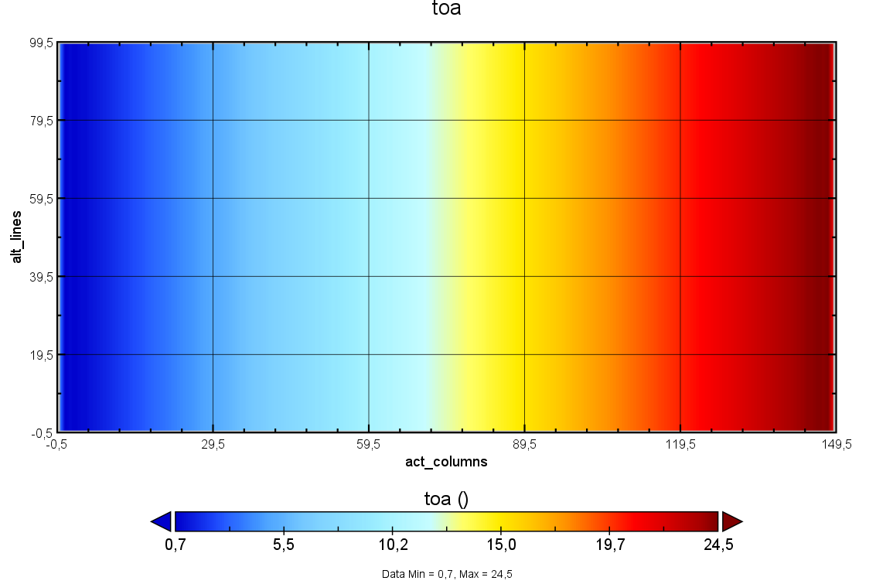

Figure 4‑13: Plot ism_toa_optical_VNIR-1.

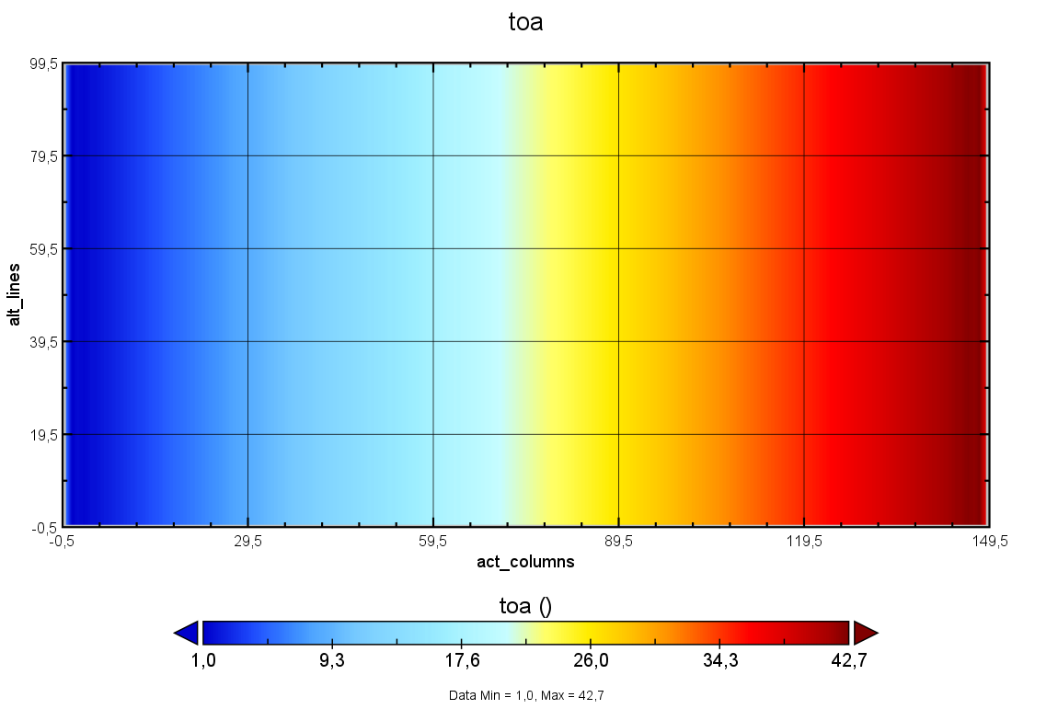

Figure 4‑14: Plot ism_toa_optical_VNIR-2.

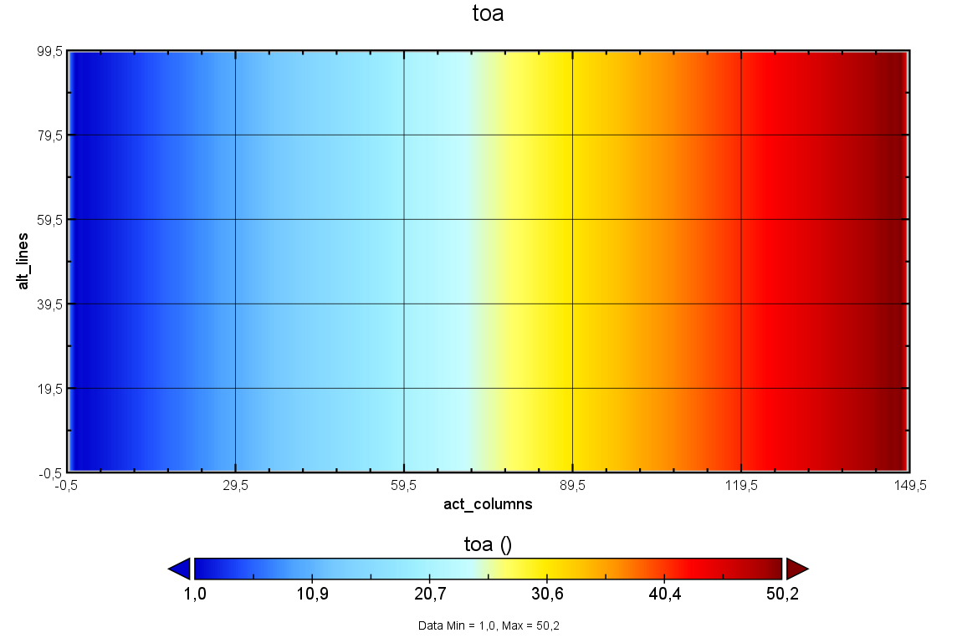

Figure 4‑15: Plot ism_toa_optical_VNIR-3.

# EODP-TS-ISM-0002. DETECTION and VIDEO CONVERSION

The goal of this test is to run the ISM Module and to check the detection and the video conversion unit

(VCU) stage. The detection stage has the irradiance to photon conversion and three effects in the chain:

❑ Photon Response Non-Uniformity (PRNU)

❑ Dark Signal (DS)

❑ Simulation of bad and dead pixels

## Pass/fail Criteria

The PASS/FAIL criteria defined for the detection and video conversion of the ISM Module contains the following test with a summarized justification of how they were obtained.

### Video and Control Unit TOA

* **Criteria**: Check for all bands that the differences with respect to the output TOA (ism_toa_) are <0.01% for at

least 3-sigma of the points.

In this section, simulations for the detection and video processing stages has been conducted. It is imperative to ensure that the disparities in the acquired TOA data, specifically after the video processing stage, exhibit minimal variation when compared to the reference output provided. To facilitate this comparison, a script named "*Test_ISM_Detect_Vid_Conversion.py*" has been developed to perform the subtraction and evaluate the discrepancies.

### Conversion Factors

* **Criteria**: What is the irradiance to photons, photons to electrons, electrons to Volts, and volts to Digital numbers conversion factor for all bands. What are the units of the TOA at each stage.

The formulas to obtain these conversion factors are summarized below:

* Irradiances to photons:

$$N_{ph}= \frac{E_{in}}{E_{photon}} [ph]$$

Where,

$E_{in}=I∙A∙t_{int} [J]$; $E_{photon,k}= \frac{hC}{λ_{k}} [J]$

$A$ is the detector element area in $m^{2}$

$t_{int}$ is the integration time in seconds

$h$ is the Planck constant in $J∙s$

$λ_{k}$ id the central wavelength for channel $k$ in meters

$C$ is the speed of light in vacuum in $m/s$

Thus, the conversion factor is given by:

$$\frac{A}{\frac{hC}{λ_{k}}}$$

The units of TOA measurements at this stage are expressed in irradiances as [mW/m²]. Following the conversion process, these TOA units are transformed into irradiances, denoted as [$photons$].

* Photons to electrons:

$$N_{e}= N_{ph}∙QE [e^{-}].$$

Where

$QE$ is the quantum efficiency in $e/ph$

Thus, the conversion factor is:

$$QE$$

The units of TOA measurements at this stage are [$photons$]. Following the conversion process, these TOA units are [$e^{-}$].

* Electrons to Volts:

$${TOA}_{v}= N_{c}∙OCF∙Gain$$

Where

$OCF$ is the Output Conversion Factor

$Gain$ is the system gain

Thus, the conversion factor is given by:

$$OCF∙Gain$$

The units of TOA measurements at this stage are [$e^{-}$]. Following the conversion process, these TOA units are [$V$].

* Volts to Digital Numbers:

$${TOA}_{DN}=round\left(\frac{{TOA}_{v}}{V_{max}-V_{min}}\right)∙(2^{bitdepth}-1)$$

The units of TOA measurements at this stage are [$V$]. Following the conversion process, these TOA units are converted to digital numbers.

### Image ‘Stripes’

* **Criteria**: Explain why there are ‘stripes’ in the image, and why they are in the ALT direction.

Explanation given in section [5.3.3].

### Saturated Pixels

* **Criteria**: For all bands, check whether there are any saturated pixels. Quantify the percentage of saturated

pixels per band.

To determine the presence of saturation in all spectral bands, TOA plots after the execution of the detection and video processing stages will be presented, with a focus on the central ALT position. These plots serve to assess the quantity of saturated pixels, if any.

### TOA Plots

* **Criteria**: Plot the TOA for all bands after the detection and the VCU stages (with Panoply).

Following the completion of detection and video conversion stages, the TOA plots will be displayed using Panoply in section [5.3.5].

## Summary: PASS/FAIL

This exercise is a **PASS**.

## Test Results

### Video and Control Unit TOA









Figure 5‑1: Video and Control TOA Difference Check.

### Conversion Factors

Table 5‑1: Conversion Factors Values for all Bands

|  |  |  |  |  |
| --- | --- | --- | --- | --- |
|  | **Irradiance to Photons** | **Photons to Electrons** | **Electrons to Volts** | **Volts to Digital Numbers** |
| **VNIR-0** | 14918705.378 | 0.8 | 3.024E-6 | 4762.0 |
| **VNIR-1** | 20246814.441 | 0.8 | 3.024E-6 | 4762.0 |
| **VNIR-2** | 26336081.943 | 0.8 | 3.024E-6 | 4762.0 |
| **VNIR-3** | 28771788.943 | 0.8 | 3.024E-6 | 4762.0 |

### Image ‘Stripes’

The presence of stripes, as exemplified in Figure 5‑2, results from a combination of various factors, such as:

* Photo Response Non-Uniformity (PRNU): This effect arises due to slight variations in how each pixel responds to incoming radiation. Consequently, for a given input irradiance, the read-out values of individual pixels exhibit variations.
* Bad/Dead Pixels: Within the Charge-Coupled Device (CCD), certain pixels may either fail to function entirely (referred to as "dead" pixels) or provide inaccurate readout values (referred to as "bad" pixels). In both scenarios, the readout values are diminished, leading to the appearance of stripes in the image.

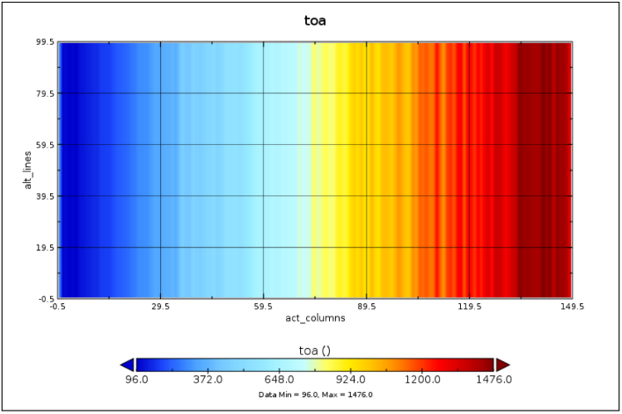

Figure 5‑2: Plot of the final TOA in DN.

### Saturated Pixels









Figure 5‑3: Percentage of Saturated Pixels per Band.

### TOA Plots

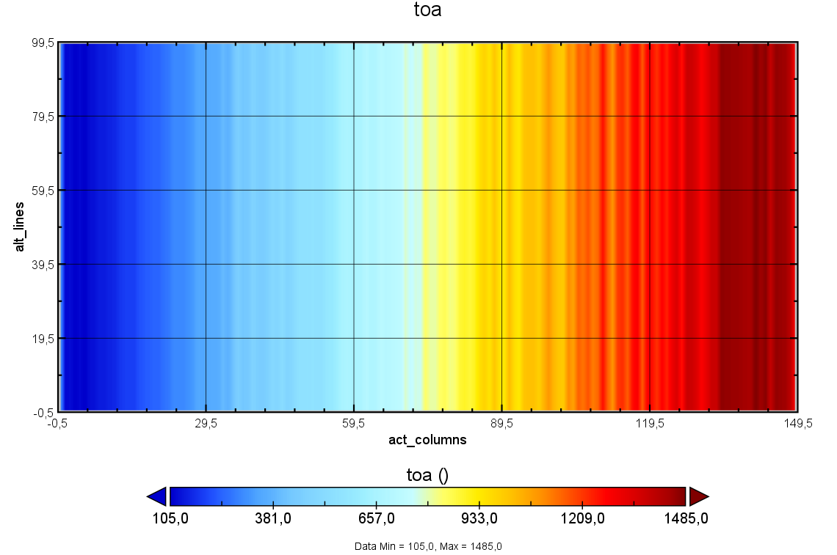

Figure 5‑4: Plot ism_toa_VNIR-0.

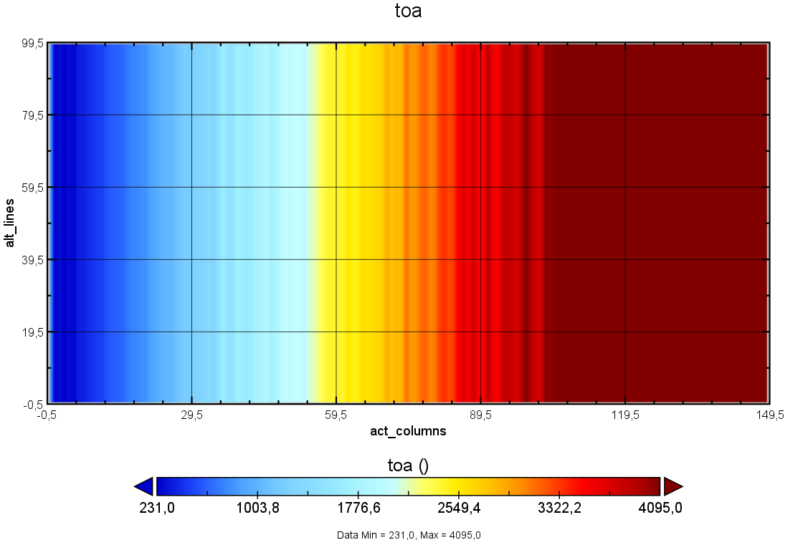

Figure 5‑5: Plot ism_toa_VNIR-1.

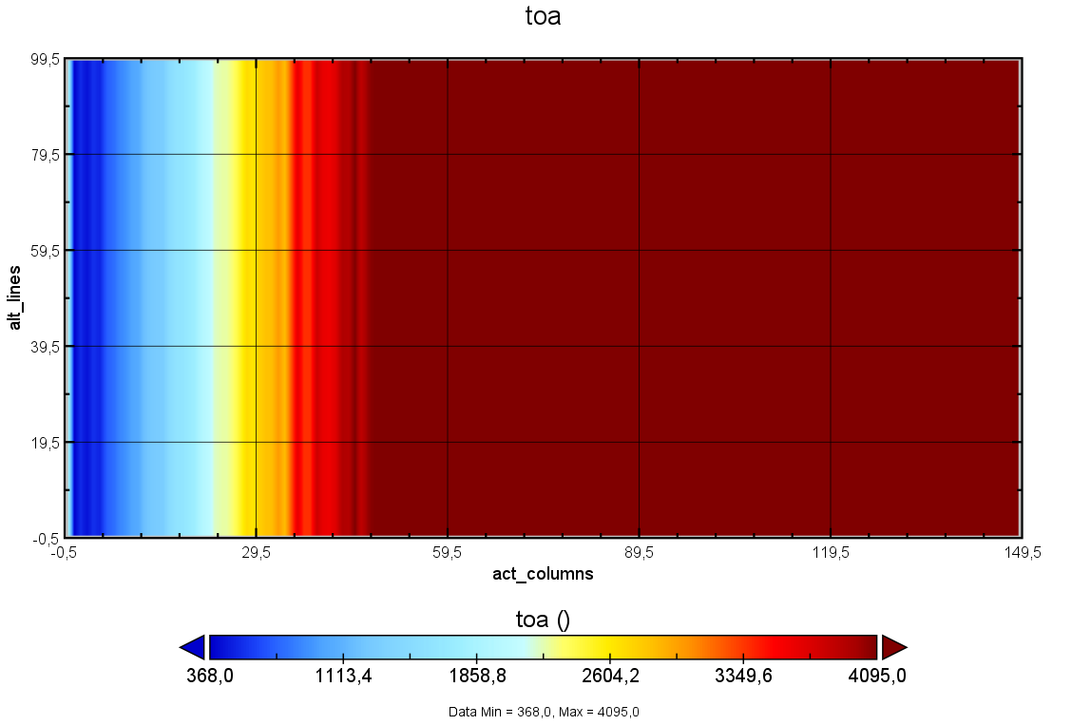

Figure 5‑6: Plot ism_toa_VNIR-2.

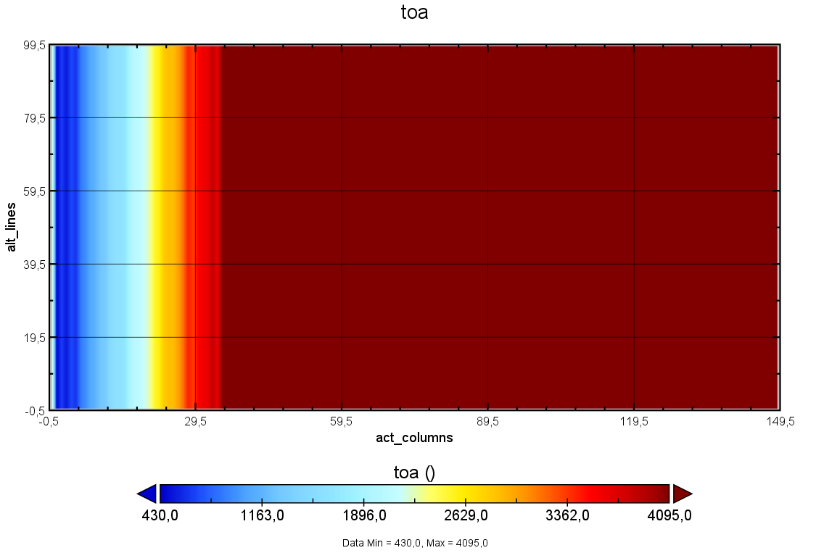

Figure 5‑7: Plot ism_toa_VNIR-3.

# EODP-TS-L1B-0001. EQUALIZATION AND RESTORATION

The goal of this test is to run the L1B Module and to check the equalization and restoration of the signal.

## Pass/fail Criteria

The PASS/FAIL criteria defined for the equalization and restoration of the L1B Module contains the following test with a summarized justification of how they were obtained.

### LIB TOA

* **Criteria**: Check for all bands that the differences with respect to the output TOA (l1b_toa_) are <0.01% for at

least 3-sigma of the points.

The L1B module, incorporating equalization, has been developed and subjected to simulation. It is imperative to scrutinize the disparities in the acquired TOA and ensure their conformity with the reference output. To facilitate this comparative analysis, a script named "*Test_L1b_Restoration_&_Equalization.py*" has been devised to execute the subtraction and evaluate the discrepancies.

### Restored Signal and TOA Plots Differences

* **Criteria**: For the central ALT position, plot the restored signal (l1b_toa), and the TOA after the ISRF (ism_toa_isrf). Explain the differences.

After conducting a comparative analysis between the L1B TOA and the reference output, the subsequent step entails contrasting the results with the TOA acquired in the context of the ISRF. This comparison is essential to discern and quantify the discrepancies in each spectral band.

### Restored Signal Equalization Comparison

* **Criteria**: Do another run of the L1B with the equalization enabled to false. Plot the restored signal for this case

and for the case with the equalization set to True. Compare.

The equalization parameter will be modified within the "*l1bConfig.py*" script, setting it to "False." This adjustment is made to exclude the influence of equalization effects, facilitating a comparative analysis with equalized results to assess the impact of this process.

### Blocked Restoration

* **Criteria**: Can you explain why the restoration for VNIR-1 to VNIR-3 is “blocked” for radiances above

approximately 200 mW/sr/m2.

The restoration process for VNIR-1 to VNIR-3 is restricted for radiances exceeding 200 mW/sr/m² due to the presence of saturated pixels. In other words, saturated pixels solely establish a lower limit for irradiance. Further details and information on this topic can be found in section [6.3.4].

## Summary: PASS/FAIL

This exercise is a **PASS**.

## Test Results

### LIB TOA









Figure 6‑1: L1B TOA Difference Check.

### Restored Signal and TOA Plots Differences

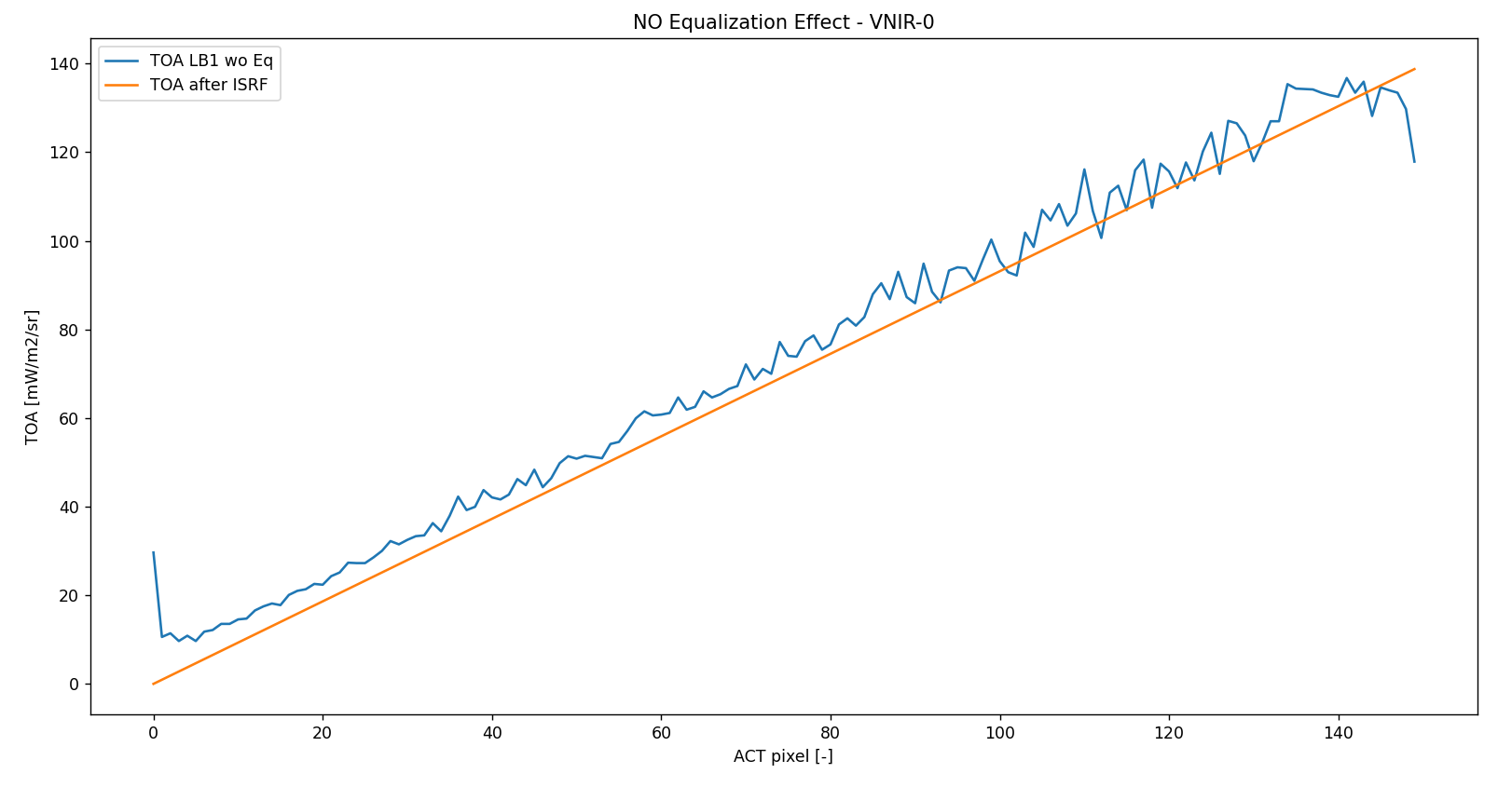

Figure 6‑2: Restored Signal vs ISRF TOA - VNIR-0 (for central ALT position).

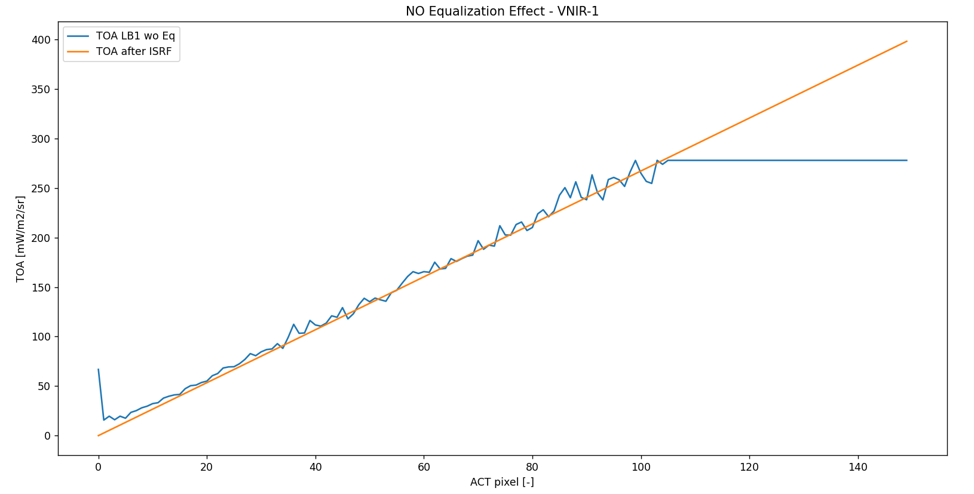

Figure 6‑3: Restored Signal vs ISRF TOA - VNIR-1 (for central ALT position).

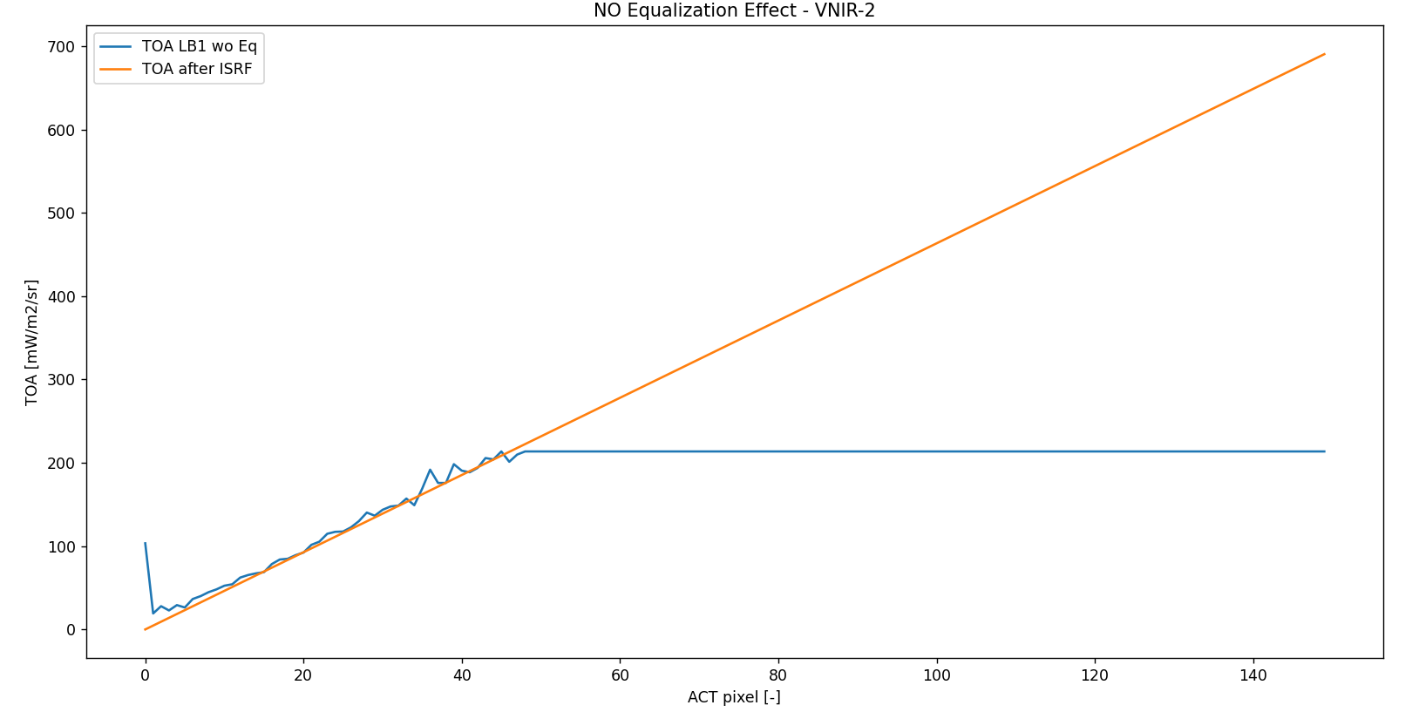

Figure 6‑4: Restored Signal vs ISRF TOA - VNIR-2 (for central ALT position).

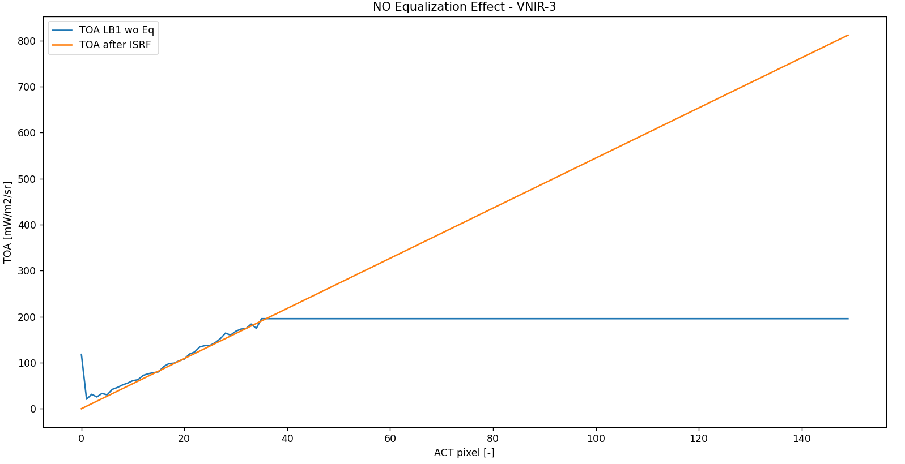

Figure 6‑5: Restored Signal vs ISRF TOA - VNIR-3 (for central ALT position).

### Restored Signal Equalization Comparison

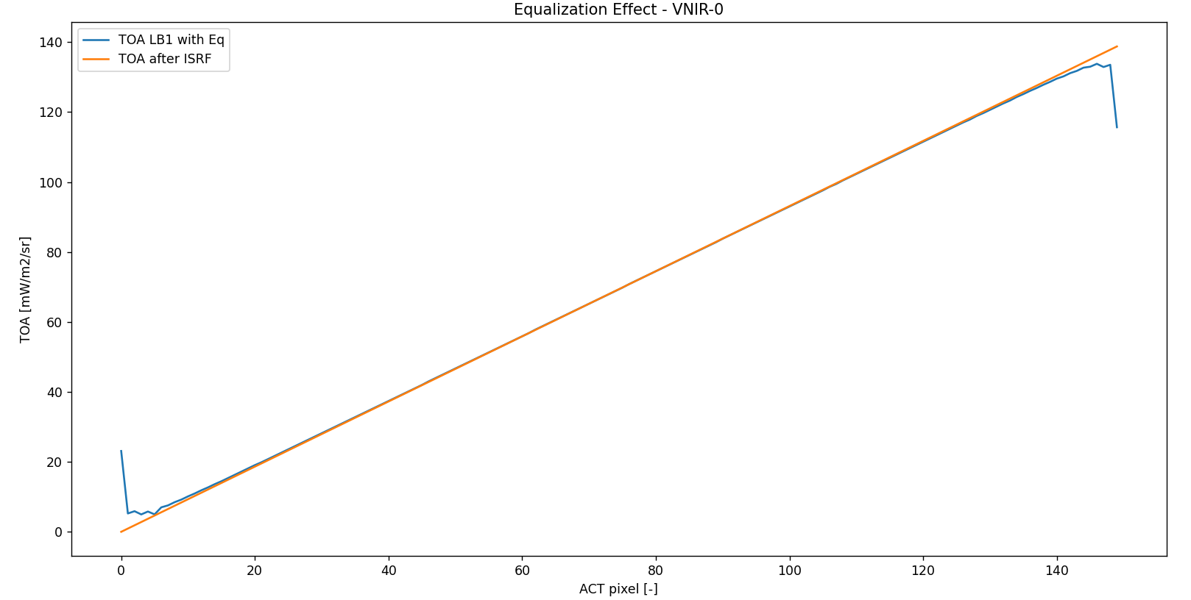

1. Equalized L1B TOA



1. Non-Equalized L1B TOA

Figure 6‑6: L1B TOA Equalization Comparison – VNIR-0.

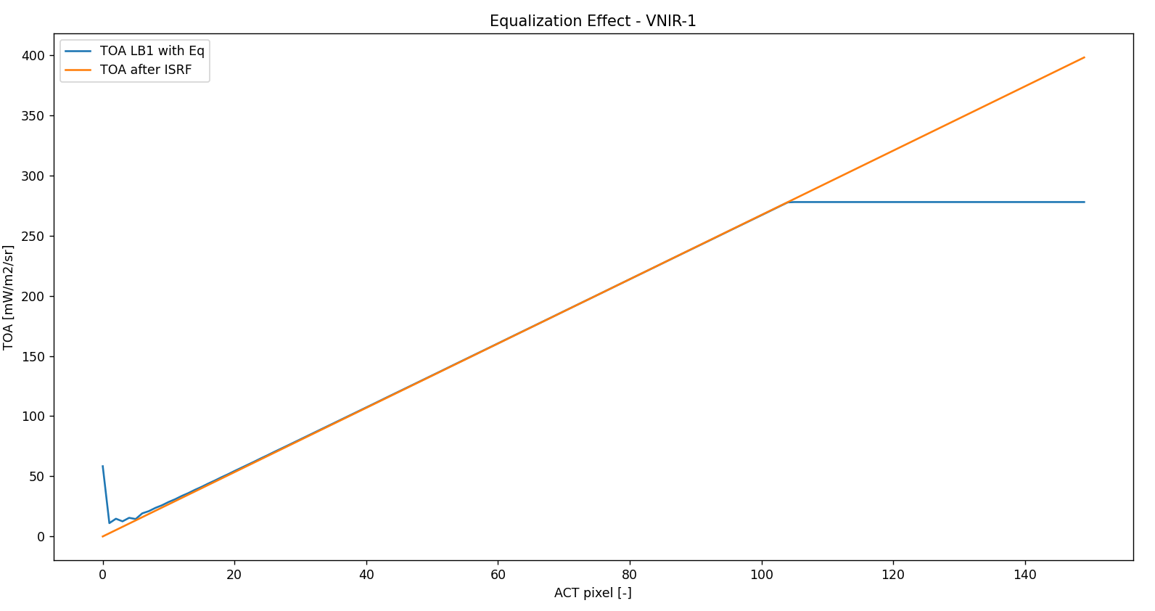

1. Equalized L1B TOA



1. Non-Equalized L1B TOA

Figure 6‑7: L1B TOA Equalization Comparison – VNIR-1.

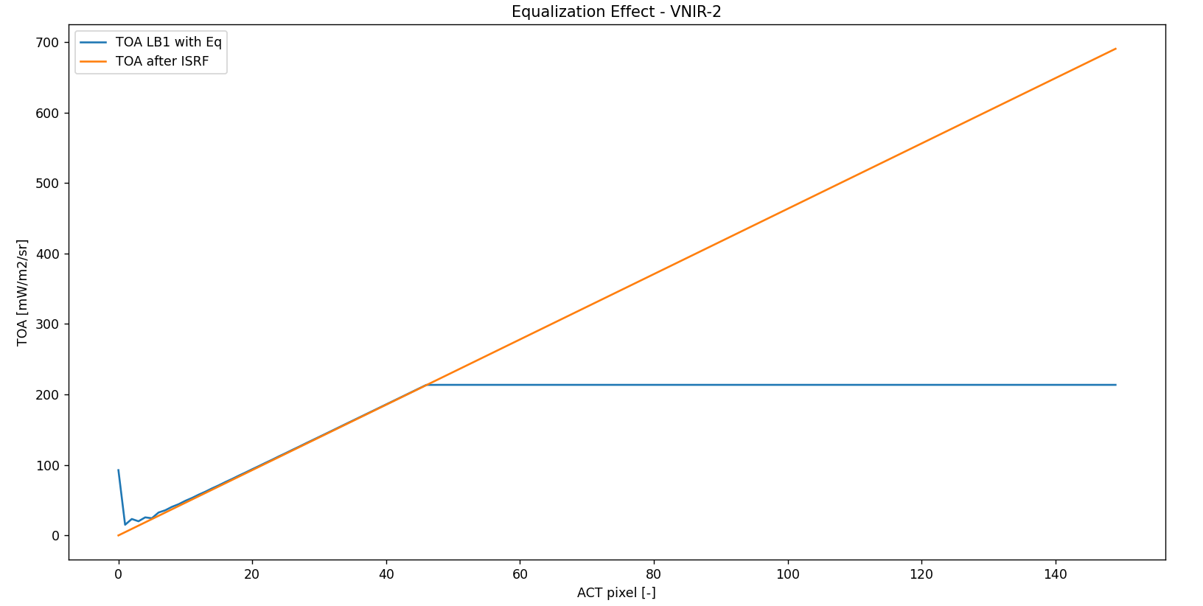

1. Equalized L1B TOA



1. Non-Equalized L1B TOA

Figure 6‑8: L1B TOA Equalization Comparison – VNIR-2.

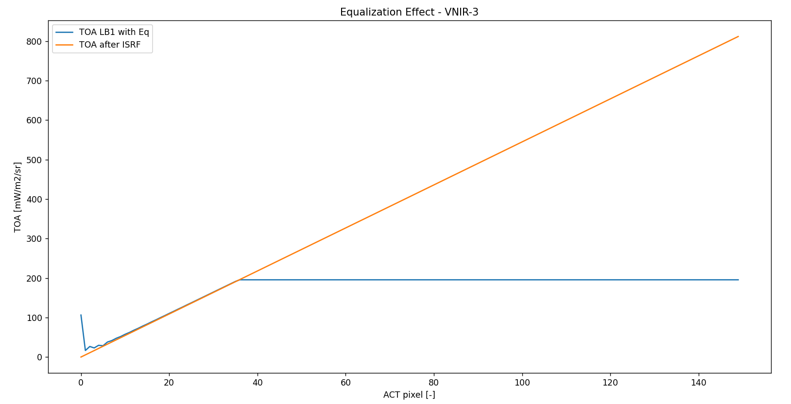

1. Equalized L1B TOA



1. Non-Equalized L1B TOA

Figure 6‑9: L1B TOA Equalization Comparison – VNIR-3.

### Blocked Restoration

As previously mentioned, the restoration process for VNIR-1 to VNIR-3 is inhibited when dealing with radiances exceeding 200 mW/sr/m², primarily due to the presence of saturated pixels. In other words, saturated pixels serve as a lower limit for irradiance. This phenomenon can be visualized in the figures of section [6.3.2].

# EODP-TS-L1C-0001. MGRS

The goal of this test is to run the L1C Module and to check the resampling of the L1B TOA into a regular

grid using the MGRS (Military Grid Reference System).

## Pass/fail Criteria

The PASS/FAIL criteria defined for the Military Grid Reference System contains the following test with a summarized justification of how they were obtained.

### L1C TOA

* **Criteria**: Check for all bands that the differences with respect to the output TOA (l1b_toa_) are <0.01% for at

least 3-sigma of the points.

The L1C module, incorporating equalization, has been developed and subjected to simulation. It is imperative to scrutinize the disparities in the acquired TOA and ensure their conformity with the reference output. To facilitate this comparative analysis, a script named " *Test_L1c_MGRS.py*" has been devised to execute the subtraction and evaluate the discrepancies.

### L1C Georeferenced TOA

* **Criteria**: Plot for all bands the L1C grid points and plot the georeferenced TOA (with Panoply). Verify that the

grid points are equispaced.

Following the implementation of L1C, it is necessary to generate plots for the georeferenced TOA using Panoply and to create plots for the grid points. The grid points are vital for evaluating the equidistance of the points.

## Summary: PASS/FAIL

This exercise is a **PASS**.

## Test Results

### L1C TOA









Figure 6‑1: L1B TOA Difference Check.

### L1C Georeferenced TOA

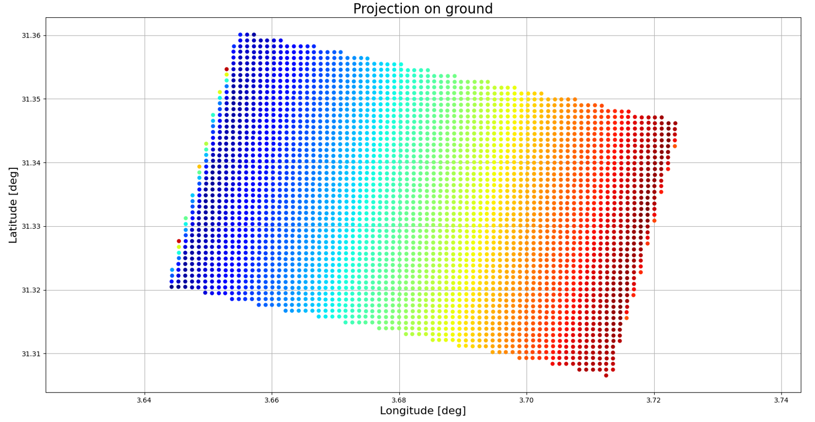

Figure 6‑1: L1C Grid Plot – VNIR-0.

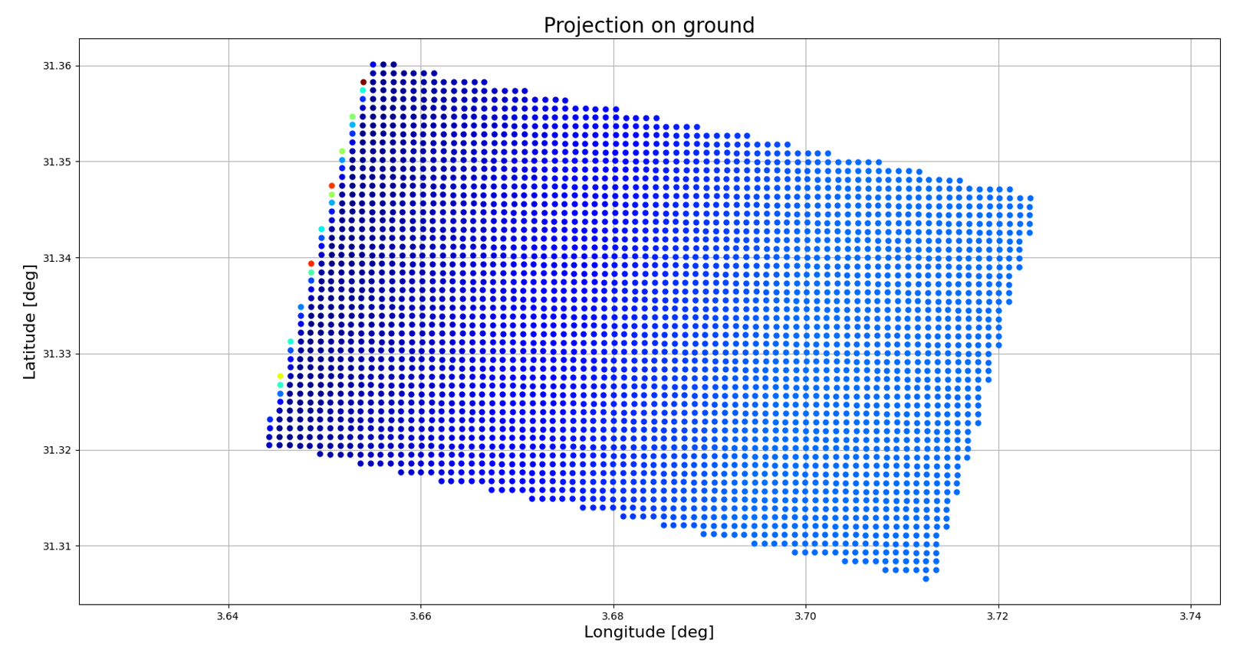

Figure 6‑1: L1C Grid Plot – VNIR-1.

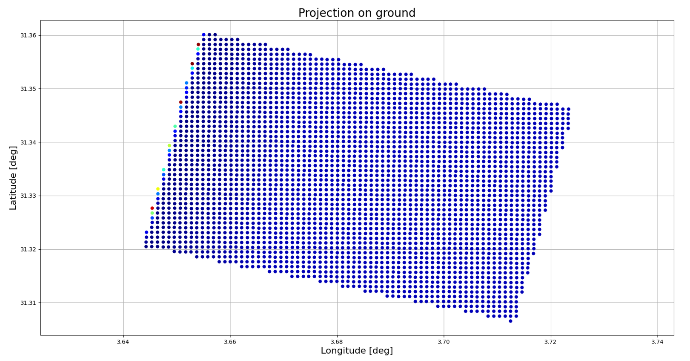

Figure 6‑1: L1C Grid Plot – VNIR-2.

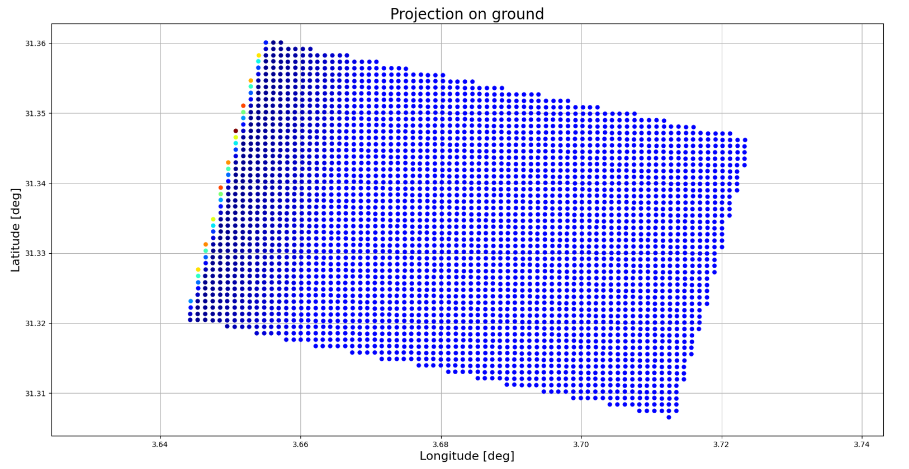

Figure 6‑1: L1C Grid Plot – VNIR-3.

# EODP-TS-E2E-0001. TLS.

The goal of this test is to run the whole simulator with a realistic scene. The selected scene is from the

Toulouse are (TLS). The mission shall be Sentinel-3 (Sentinel-3 has two multi-band imagers, OLCI and

SLSTR). The orbit is also a LTDN 10:30, similar to the one of Sentinel-2.

## Pass/fail Criteria

The PASS/FAIL criteria defined for the End to End Integration contains the following test with a summarized justification of how they were obtained.

### Modules Execution

* **Criteria**: Check that all modules run with the expected outputs.

To meet this requirement, it is only needed to execute each module of the code and verify that each module runs smoothly, producing the anticipated results without any issues.

### GM Latitudes Plot

* **Criteria**: Plot the GM latitudes (in Panoply, georeferenced plot) Notice how is over Toulouse.

The execution of the geometry module will follow the necessary scene adjustments. In this specific scenario, the *orbit_config* parameter will be modified to incorporate the Sentinel-3 orbit. Additionally, the global parameters will be revised in accordance with the guidelines provided in [EODP_SPE]. Subsequently, the GM will be visualized using Panoply to confirm the scene's location at Toulouse.

### DEM Altitudes Plot

* **Criteria**: Plot altitudes of DEM.

DEM altitudes Plot shown on section [8.3.3].

### ISM Outputs Bands Plots

* **Criteria**: Plot for all bands the outputs of the ISM, the TOA radiances after the optical, the detection and the VCU stages.

Upon completion of the ISM execution, the TOA radiances following the optical, detection, and VCU stages will be graphically represented using Panoply. Alternatively, default images provided by the Python script can also be utilized for this purpose.

### L1B Outputs Bands Plots

* **Criteria**: Plot for all bands the outputs of the L1B, the TOA . For all bands, compare the L1B TOA radiances with the TOAs after the ISRF.

Upon completion of the L1B Module, the TOA radiances will be graphically represented using Panoply. Alternatively, default images provided by the Python script can also be utilized for this purpose. Furthermore, a comparative analysis will be conducted by contrasting these radiances with those acquired in the ISM after the ISRF. To facilitate this comparison, an altitude point will be selected for both sets of radiances, and the resulting TOA data will be plotted to assess and compare the outcomes.

## Summary: PASS/FAIL

This exercise is a **PASS**.

## Test Results

### Modules Execution

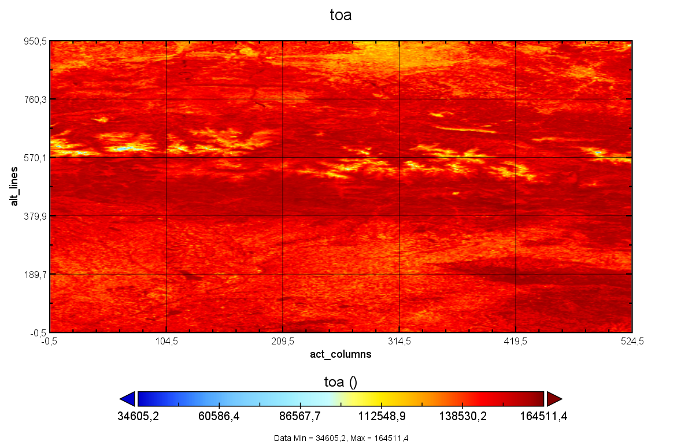

Figure 6‑1: L1C TOA ISM Detection – VNIR-0 - Reference.

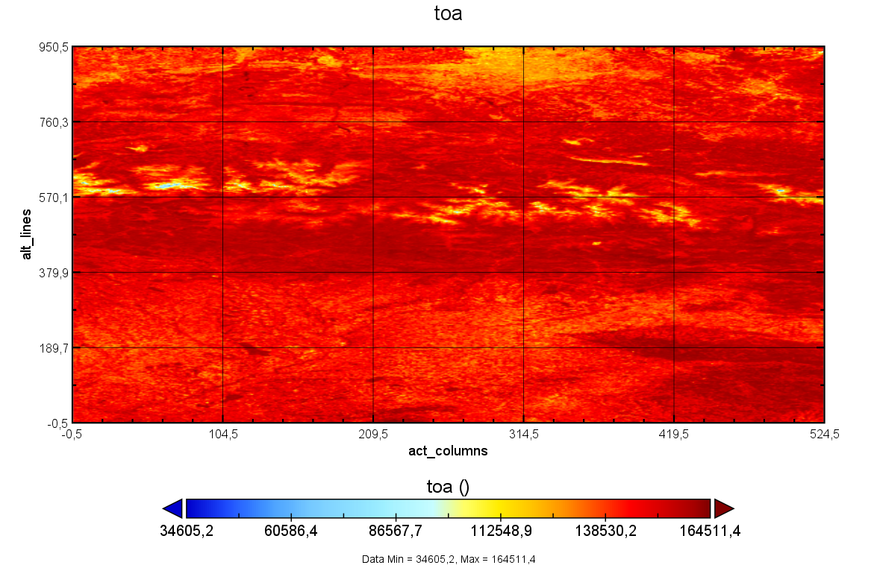

Figure 6‑1: L1C TOA ISM Detection – VNIR-0 – Output obtained.

### GM Latitudes Plot

|  |  |
| --- | --- |
|  |  |
| 1. Panoply Location, Latitude Georeferenced Plot | 1. Google Earth Location |

Figure 3‑8: Location of Data Acquisition Country for Sentinel-3.

### DEM Altitudes Plot

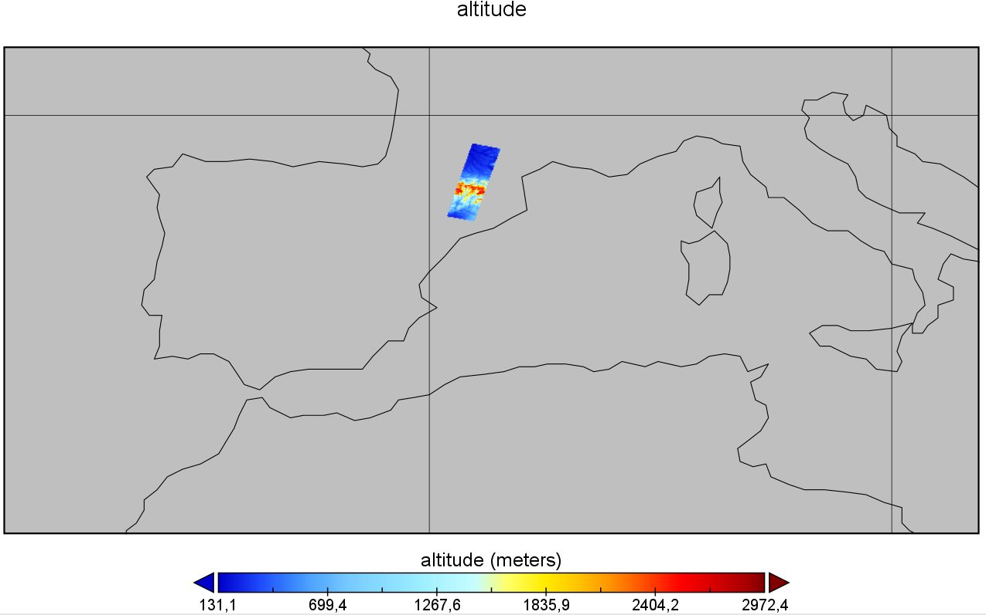

Figure 3‑9: Altitude DEM Plot.

### ISM Outputs Bands Plots

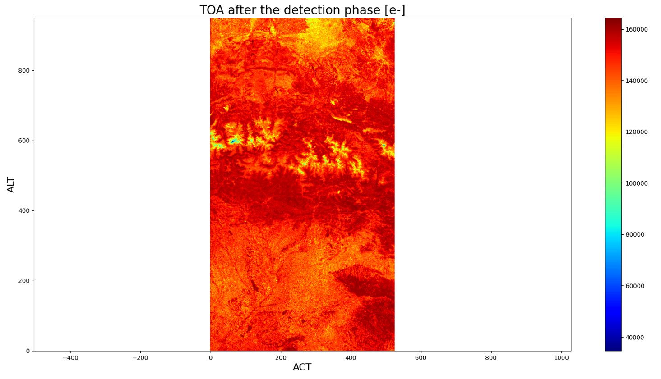

Figure 3‑9: Plot ISM TOA after the Detection Phase - VNIR-0.

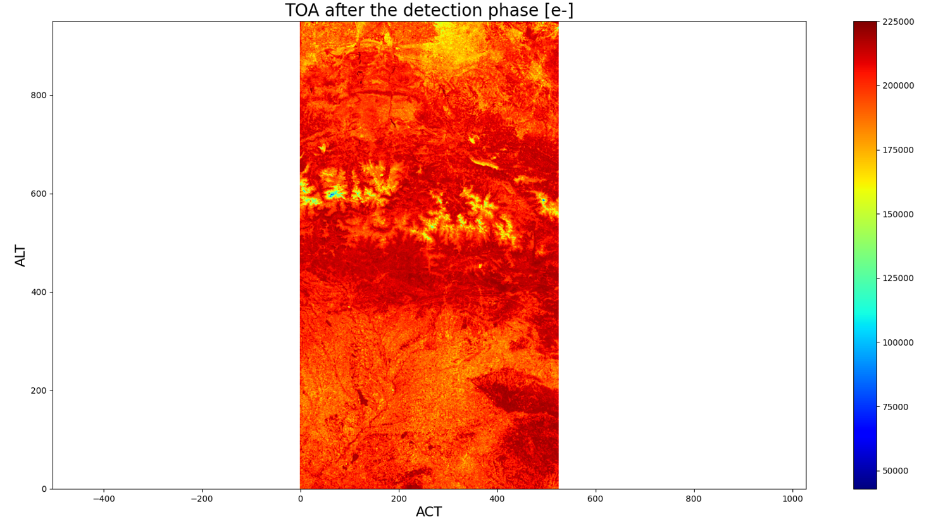

Figure 3‑9: Plot ISM TOA after the Detection Phase - VNIR-1.

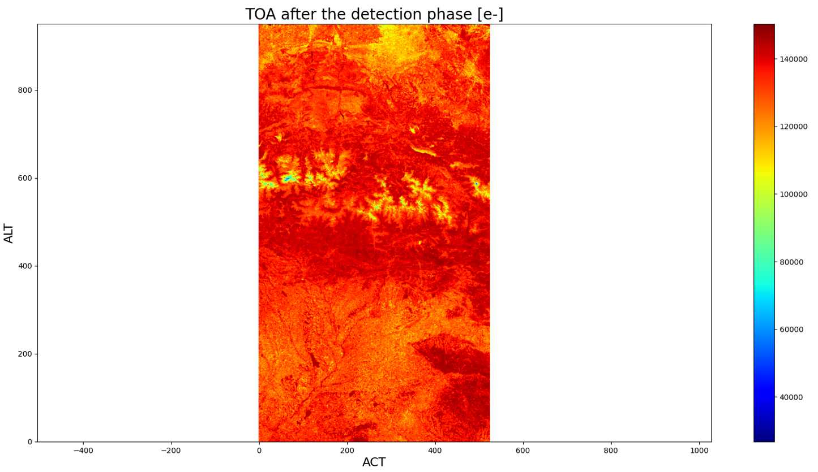

Figure 3‑9: Plot ISM TOA after the Detection Phase - VNIR-2.

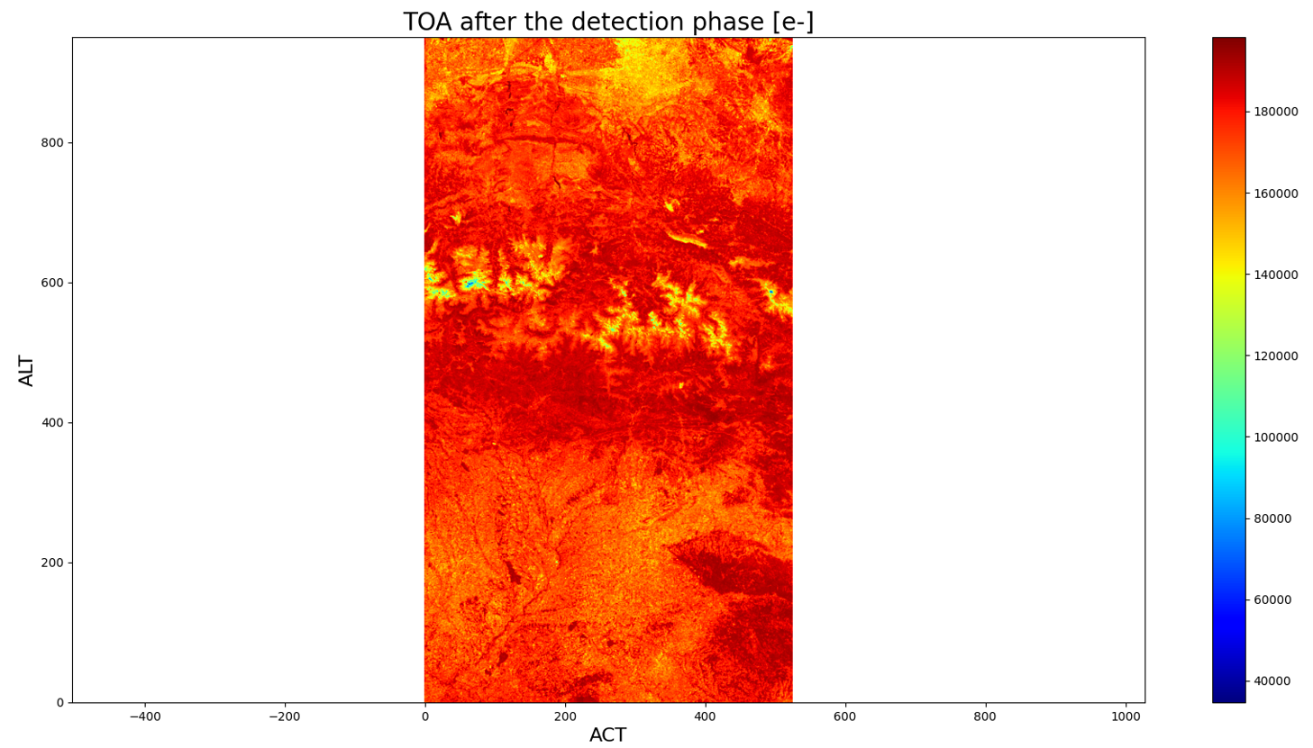

Figure 3‑9: Plot ISM TOA after the Detection Phase - VNIR-3.

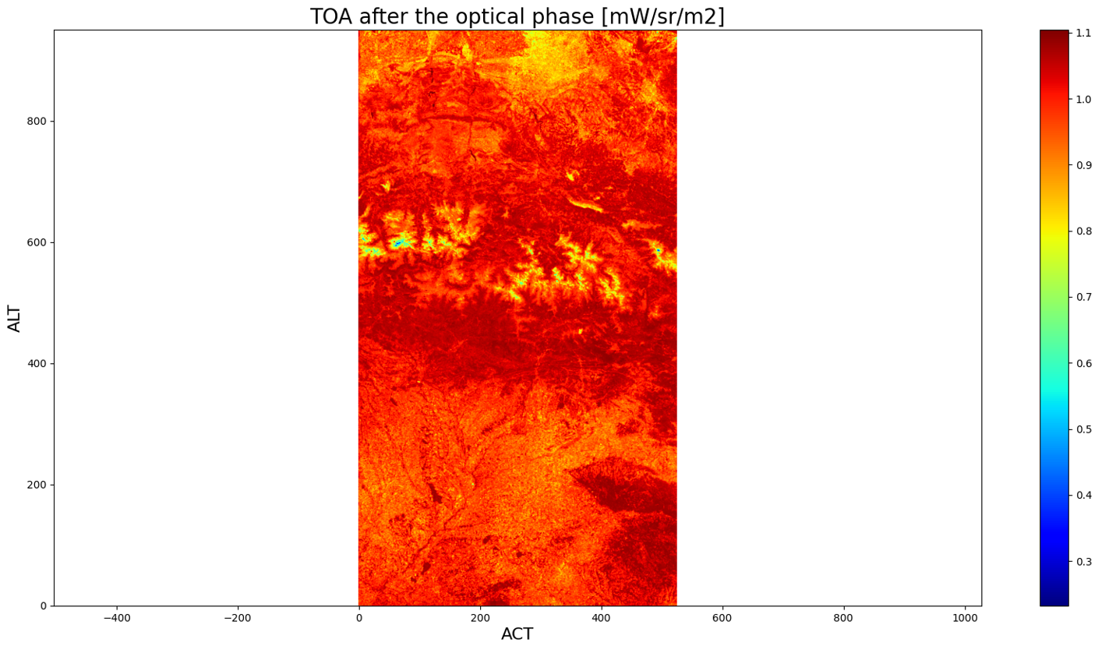

Figure 3‑9: Plot ISM TOA after the Optical Phase - VNIR-0.

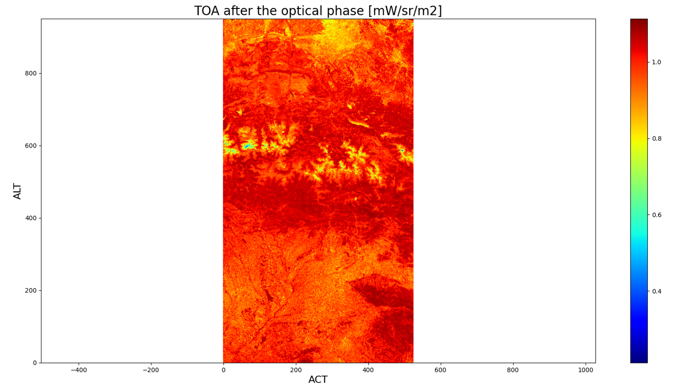

Figure 3‑9: Plot ISM TOA after the Optical Phase - VNIR-1.

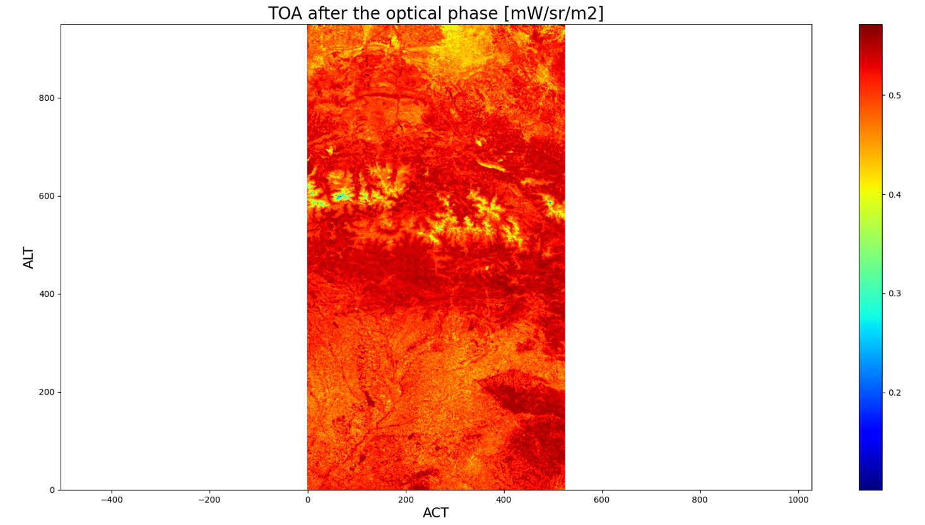

Figure 3‑9: Plot ISM TOA after the Optical Phase - VNIR-2.

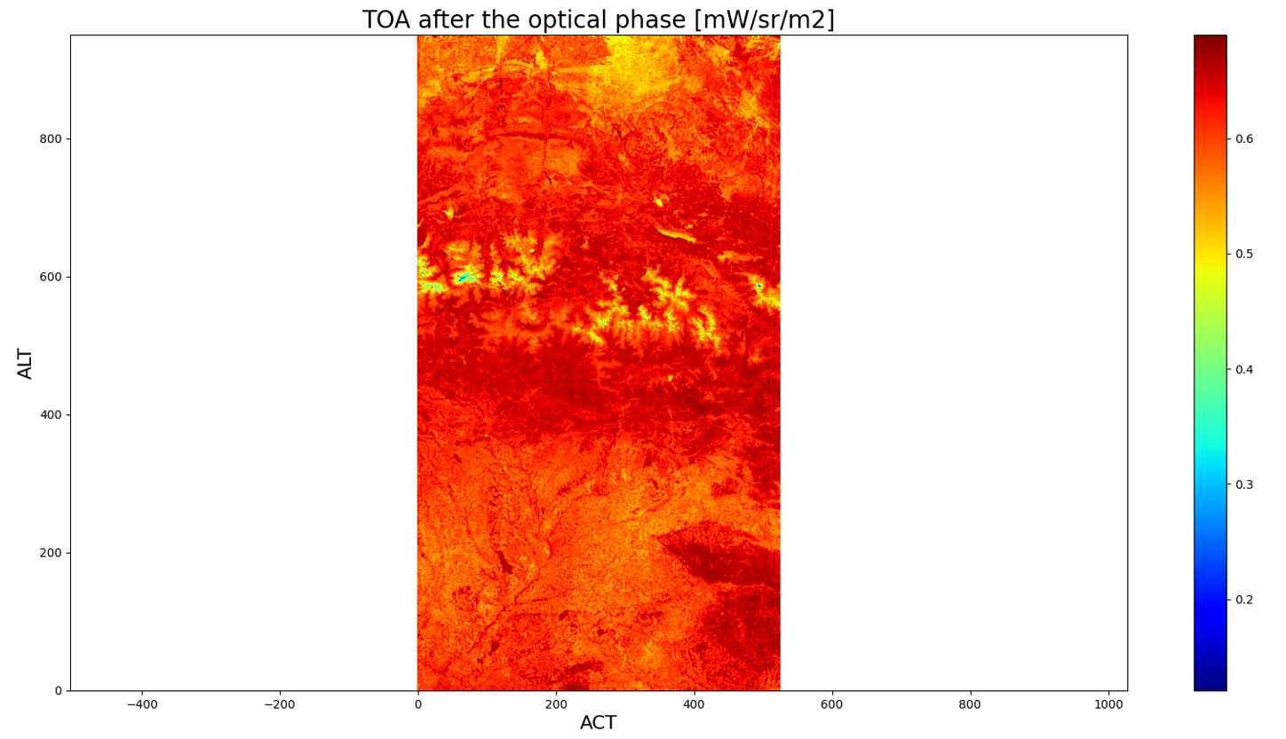

Figure 3‑9 Plot ISM TOA after the Optical Phase - VNIR-3.

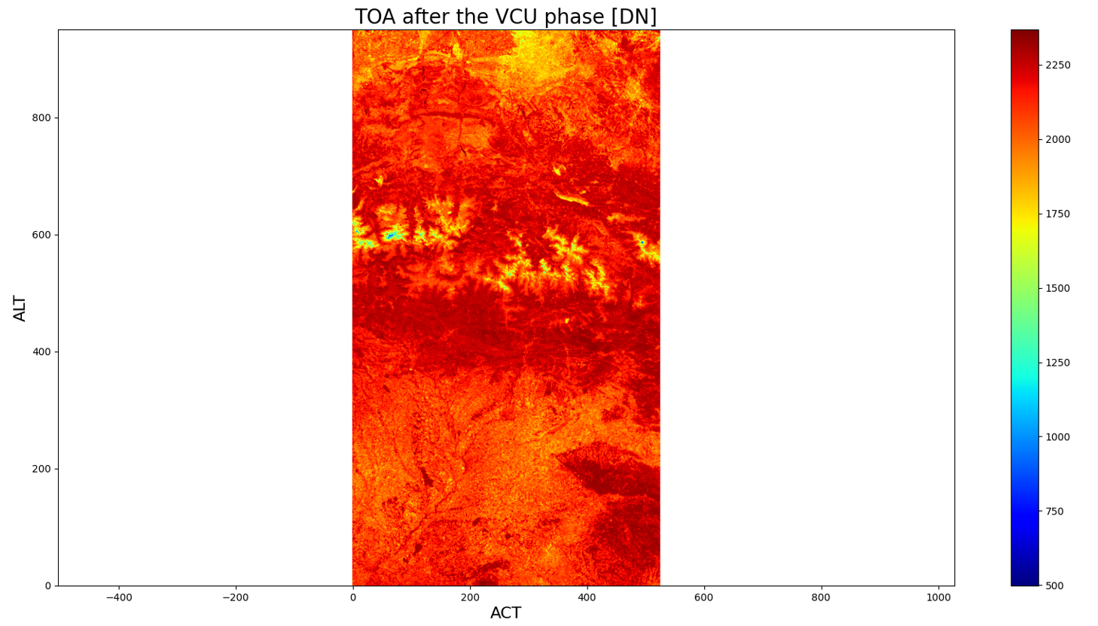

Figure 3‑9: Plot ISM TOA after the VCU Phase - VNIR-0.

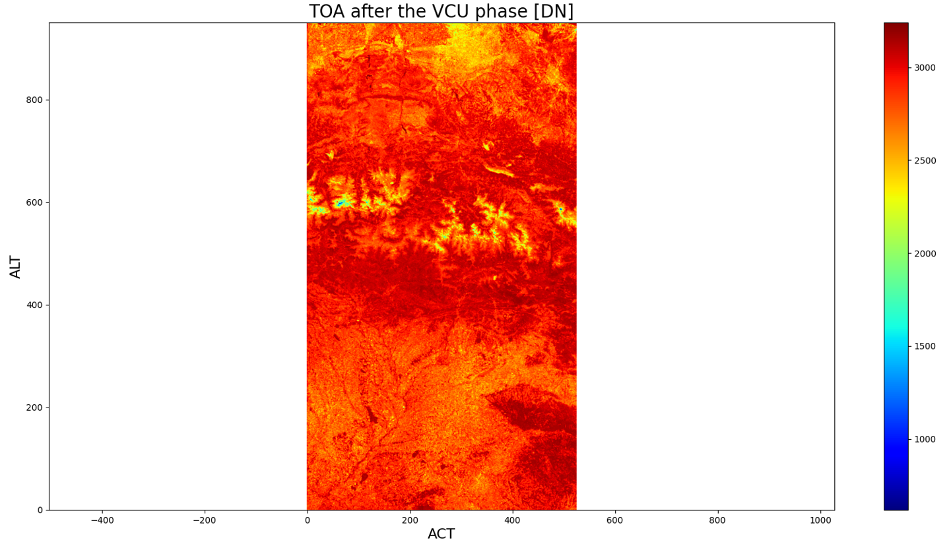

Figure 3‑9: Plot ISM TOA after the VCU Phase - VNIR-1.

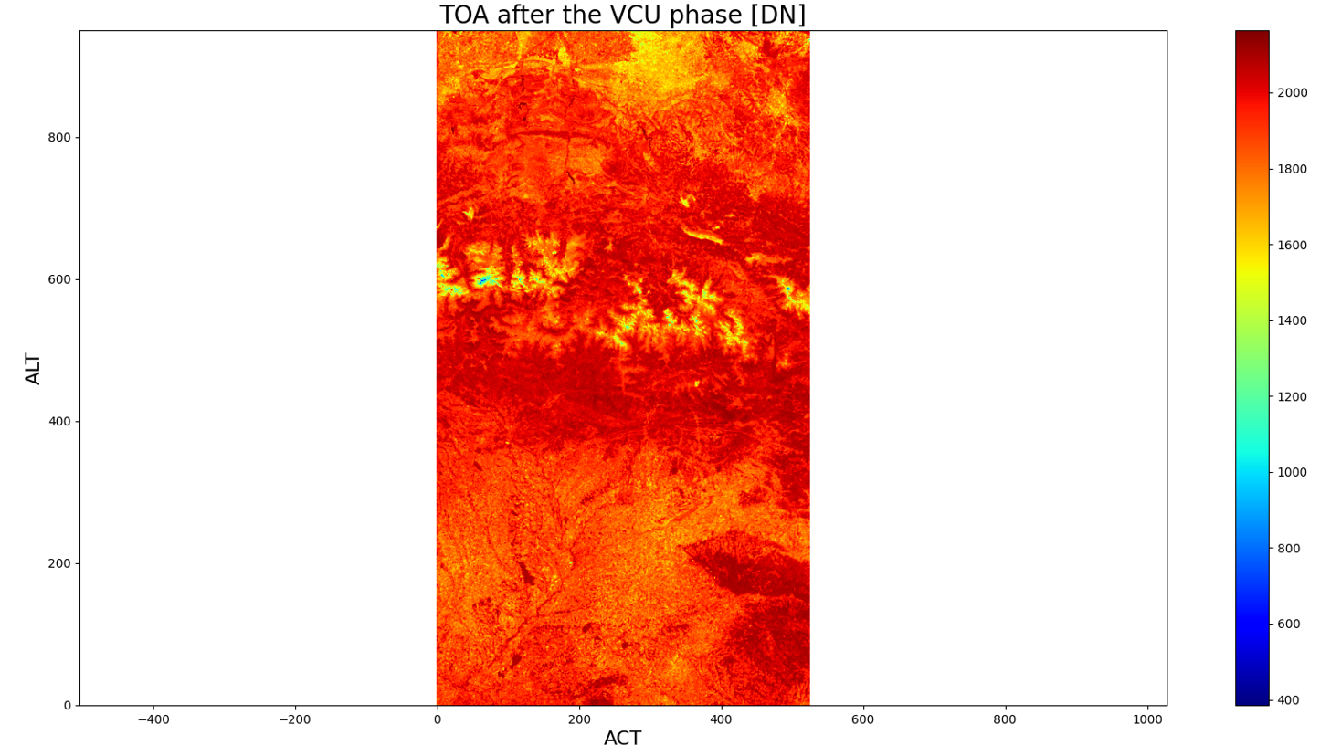

Figure 3‑9: Plot ISM TOA after the VCU Phase - VNIR-2.

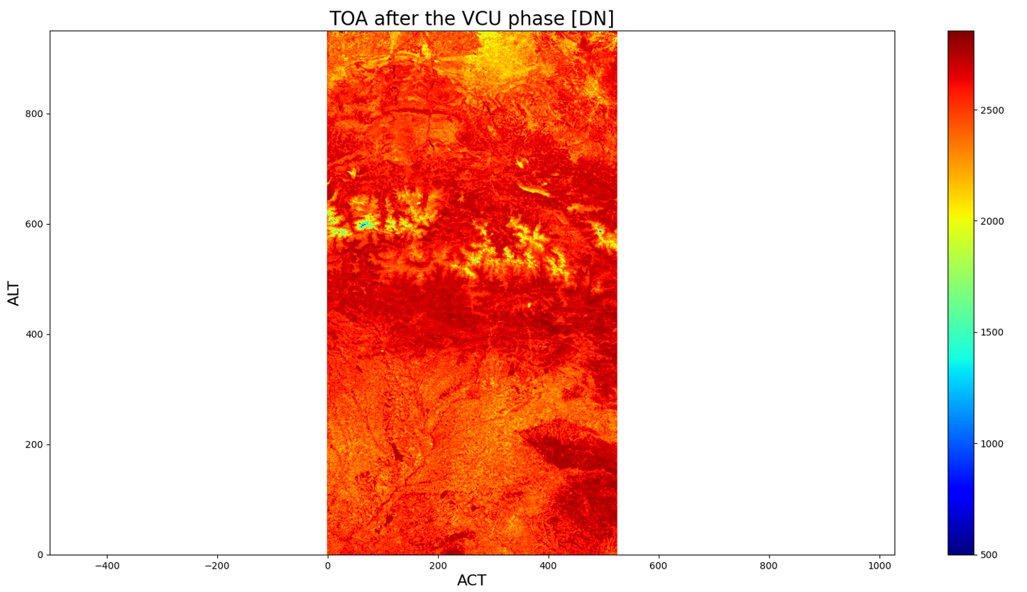

Figure 3‑9: ISM TOA after the VCU Phase - VNIR-3.

### L1B Outputs Bands Plots

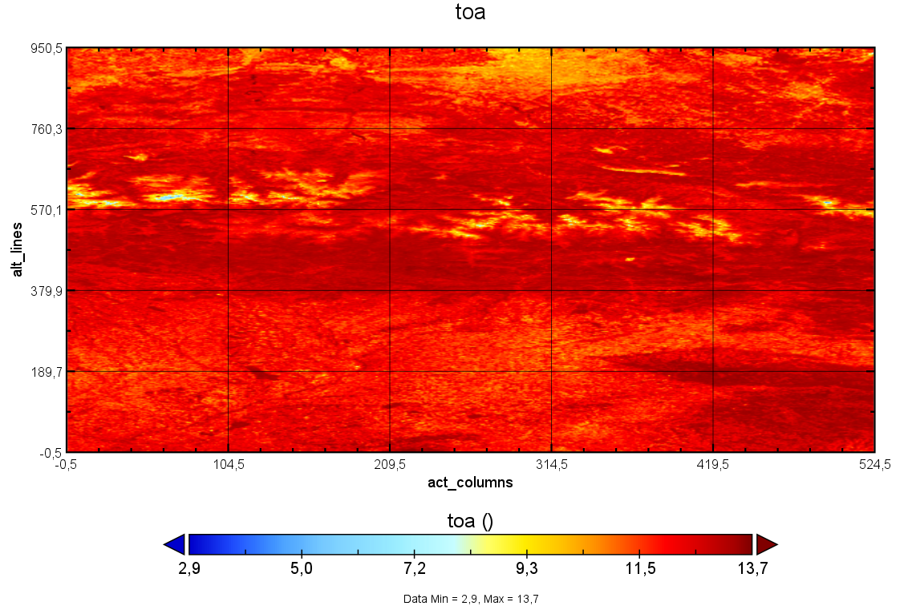

Figure 3‑9: Plot lib_toa_VNIR-0.

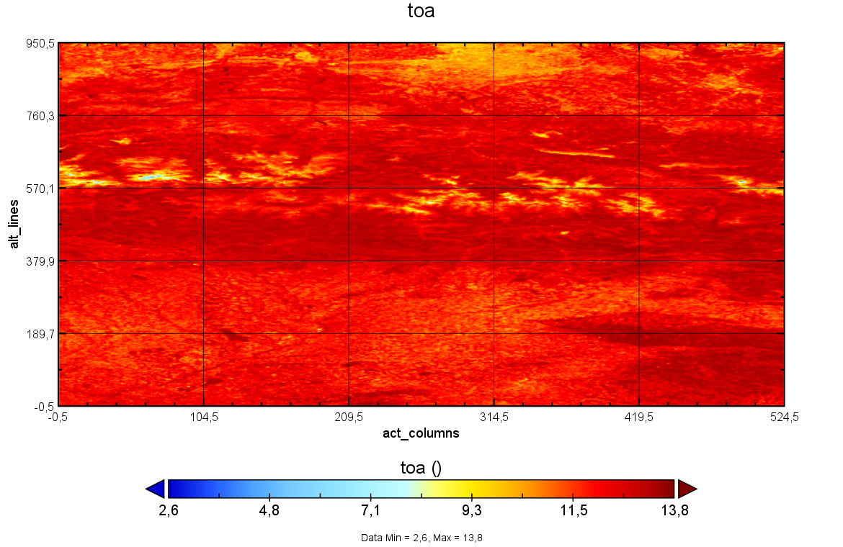

Figure 3‑9: Plot lib_toa_VNIR-1.

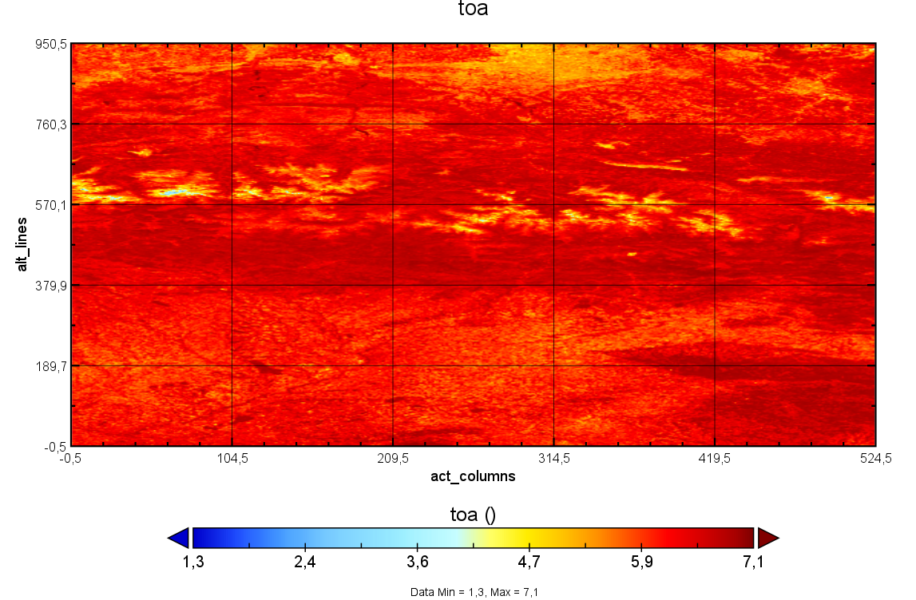

Figure 3‑9: Plot lib_toa_VNIR-2.

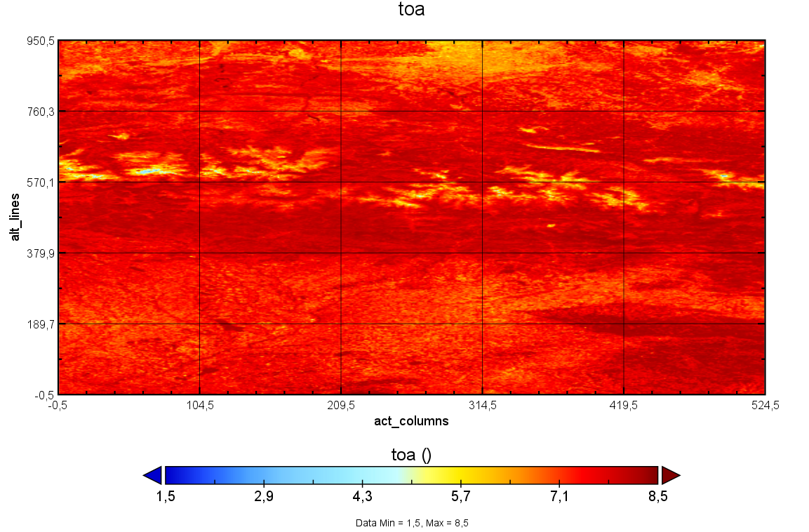

Figure 3‑9: Plot lib_toa_VNIR-3.

# Summary of test results

This table summarizes the results of the execution:

*Fill in with the results (PASS/FAIL) of the tests above.*

Table 9‑1: Summary of test execution reports

|  |  |  |
| --- | --- | --- |
| **Test ID** | **PASS/FAIL** | **Comments** |
| EODP-TS-GEO-0001 | PASS |  |
| EODP-TS-ISM-0001 | PASS |  |
| EODP-TS-ISM-0002 | PASS |  |
| EODP-TS-L1B-0001 | PASS |  |
| EODP-TS-L1C-0001 | PASS |  |
| EODP-TS-E2E-0001 | PASS |  |

END OF DOCUMENT